**Automated Testing with Selenium**

***Assignment Objective:***

The goal is to generate automated test scripts with Selenium to comprehensively assess the critical features of the Trello application.

***Assignment Tasks:***

1. ***Test Scenario Identification:***
2. **Key Features of Trello:**
3. *User Authentication*: To use Trello, users must register themselves by providing valid email followed by email verification. Users can only login with correct credentials. This authentication ensures that only authorized users can see their workspaces.
4. *Create and Manage Board:* Trello allows user to create and manage board with features like change visibility, rename, invite other members to join the board and delete board.
5. *List and Card creation:* User can create lists and tasks within the list which helps them to organize work. User can add details to the card like description, comments, due dates etc. And move card from one list to another by drag and drop. List comes with an archive feature which helps user to archive the list once tasks are completed. Typically list starts with default “To Do," "Doing," and "Done" lists, and you can add more as needed.
6. *Workspace for teams:* User can create dedicated workspace and invite other members where they can collaborate. Team members in same workspace can comment and update progress in the tasks. Admin can change the privacy of the workspace, add or remove the team members and delete workspace once work is completed.
7. *Notifications:* Users will get notify with mentions, due date reminders and board activities.
8. *Search and Filtering:* User can search the board, cards and members. User have filter option to narrow down search results.
9. *User profile management:* User can update personal information and profile visibility and manage account settings*.*
10. *Trello Templates:* Trello templates are pre-designed boards with lists and cards, often tailored for specific purposes or common use cases. They are a convenient way for Trello users to kickstart their projects and workflows without having to create boards and lists from scratch.
11. *Activity Information*: User can see all the activities performed by user profile including login history.
12. *Logout*: User can logout securely with all work saved in his profile with logout option.
13. **Critical test scenarios and functionalities to be tested using Selenium:**

|  |  |  |
| --- | --- | --- |
| **No.** | **Test Scenario** | **Functionality** |
| 1. | Verify that user can successfully login with valid credentials into Trello account. *(Login Happy Path)* | User Login |
| 2. | Verify that user cannot login with invalid password. |
| 3. | Verify that user cannot login with blank password. |
| 4. | Verify that user can successfully login and logout with valid credentials. *(Login Logout Happy Path)* |
| 5. | Verify that user can create board with required information. *(Board Creation Happy Path)* | Create and Manage Board |
| 6. | Verify that user can change board visibility. |
| 7. | Verify that user can delete the board. *(Board Deletion).* |
| 8. | Verify that user cannot sign up with blank email Id. | Sign Up |
| 9. | Verify that user cannot sign up with invalid email Id. |
| 10. | Verify that user can sign up with valid email Id. *(Sign Up Happy path)* |
| 11. | Verify that user can create list with card. *(List and Card Creation Happy Path)* | Create and Manage List and Card |
| 12. | Verify that user can update the card with description details and comment. |
| 13. | Verify that user can archive the selected list. |
| 14. | Verify that user can create workspace with required information. *(Workspace Creation Happy Path)* | Create and Manage Workspace |
| 15. | Verify that user can change workspace visibility. |
| 16. | Verify that user can invite workspace members. | Create and Manage Workspace |
| 17. | Verify that user can delete the workspace. |

***2.Test Script Creation:***

1. Set up a testing environment using Selenium WebDriver and used Java programming language to automate test scripts.
2. Created below test scripts for the above test scenarios with assertions:
3. *Trello_LoginTests.java:* This test script covers User Login functionality which includes test scenarios: Login Happy Path, Login with Incorrect Password, Login with blank password and Login Logout Happy Path.

Includes below assertions:

1. Assertion to verify success login:

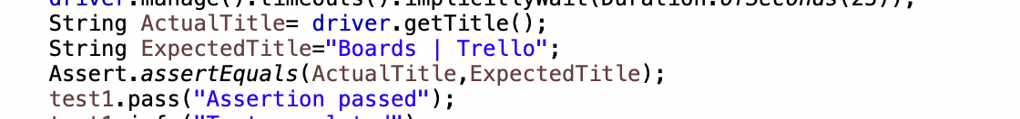

1. Assertion to verify incorrect password error:



1. Assertion to verify blank password error:

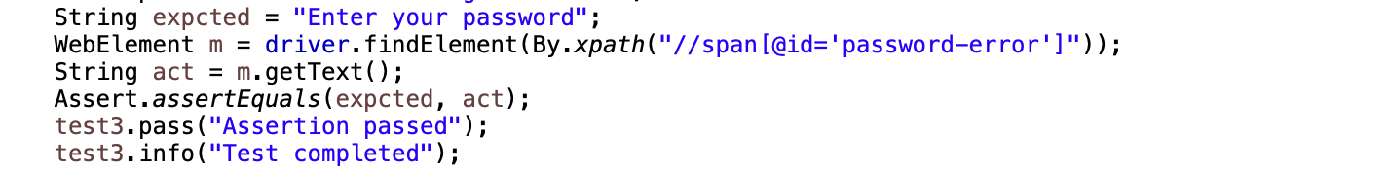

1. *BoardTests.java:* This test script covers Create and Manage Board functionality which includes test scenarios: Board Creation Happy path, Change Board Visibility and Board Deletion.

Includes below assertions:

1. Assertion to verify board title:



1. Assertion to verify board visibility change message:

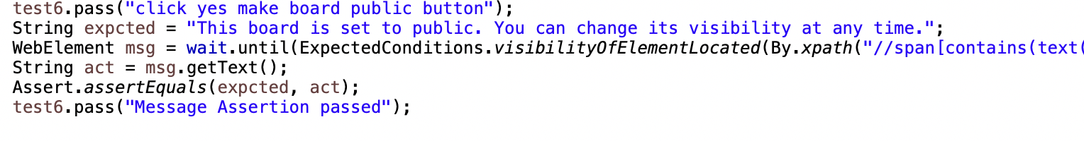

1. *Trello_SignUpTests.java:* This test script covers Sign Up functionality which includes test scenarios: Sign Up with blank email Id, Sign Up with invalid email, Sign Up happy path.
   1. Assertion to verify blank email error message:

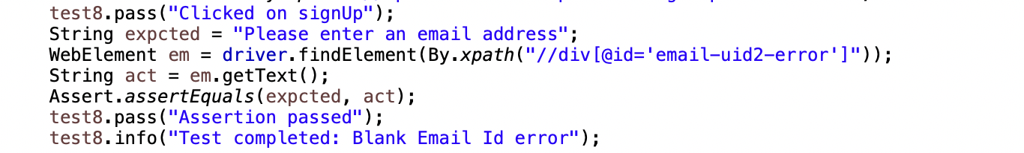

* 1. Assertion to verify invalid email error message:



1. *Trello_CreateListTests.java:* This test script covers Create and Manage List and Card functionality which includes test scenarios: List and Card Creation Happy Path, Update Card and Archive the list.
2. *Trello_WorkspaceForTeamTests.java:* This test script covers Create and Manage Workspace functionality which includes test scenarios: Workspace Creation Happy path, Change Board Visibility, Invite Workspace Members and Board Deletion.

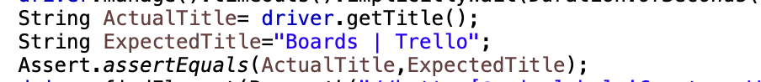

***Task 3 and 4: Reporting and Text Execution and Documentation***

I have used Extent Report library in Selenium that provides detailed test reports.

**Functionality 1: User Login**

***Test 1: Verify that user can successfully login with valid credentials into Trello account. (Login Happy Path)***

Login Test Input:

Output: Login Successful. Assertion passed for page title.

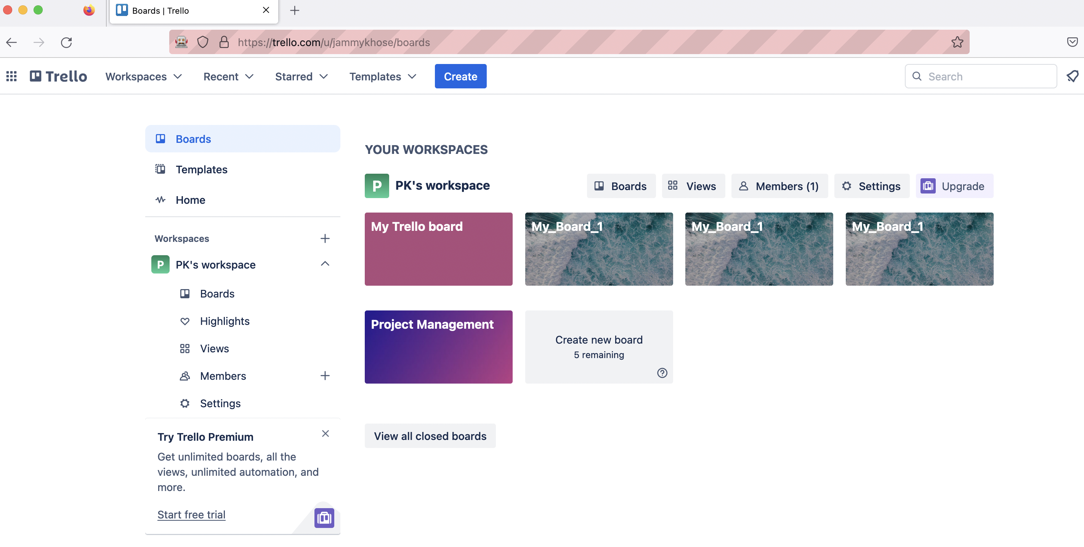

Test 1: Report  
  
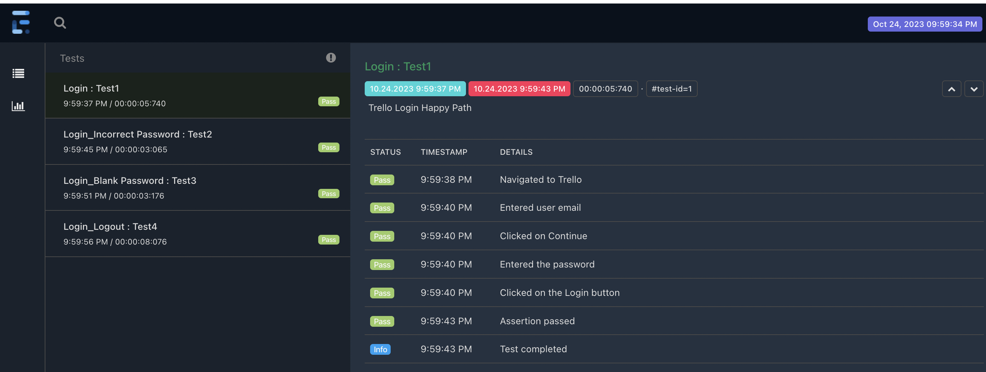

**Test 1 status: Pass**

***Test 2: Verify that user cannot login with invalid password.***

User got expected error message. Message verified with the assertion.

Test 2: Report

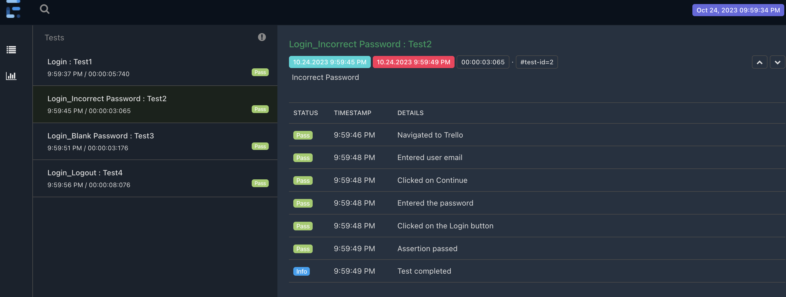

**Test 2 status: Pass**

***Test 3: Verify that user cannot login with blank password.***

User got expected error message. Message verified with the assertion.

Test 3: Report

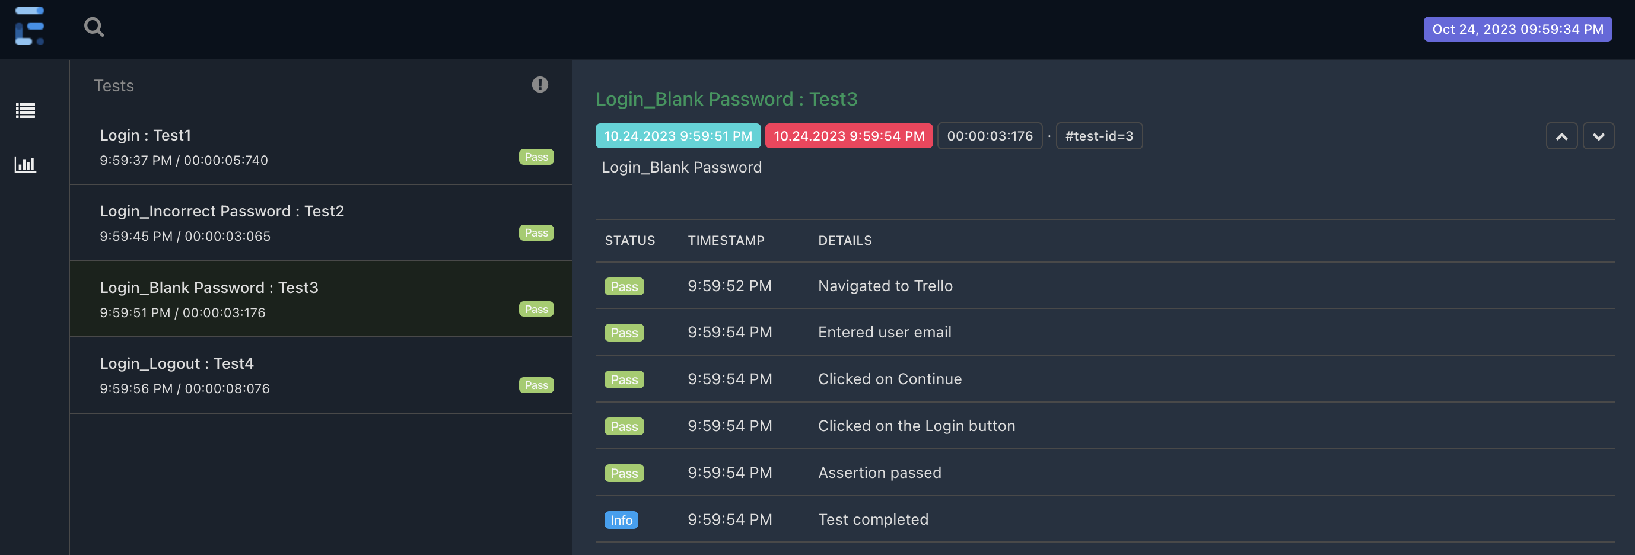

**Test 3 status: Pass**

***Test 4: Verify that user can successfully login and logout with valid credentials. (Login Logout Happy Path)***

By clicking on log out from profile user successfully logged out from Trello account.

Test 4: Report

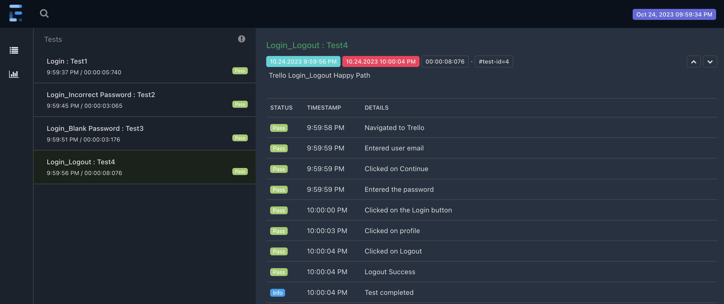

**Test 4 status: Pass**

**Trello_LoginTests Suite Report:**

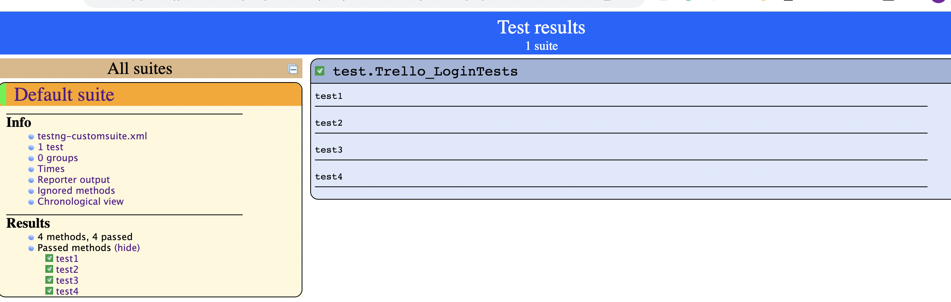



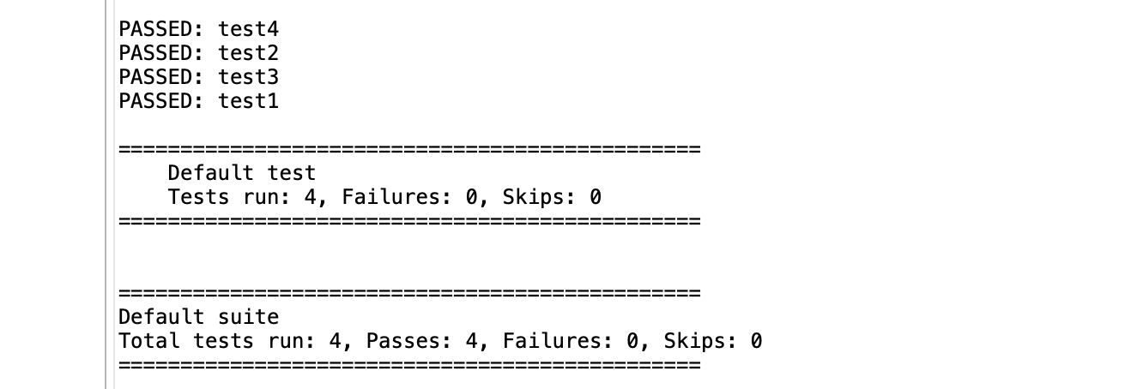

All test cases from Login Test suite are passed.

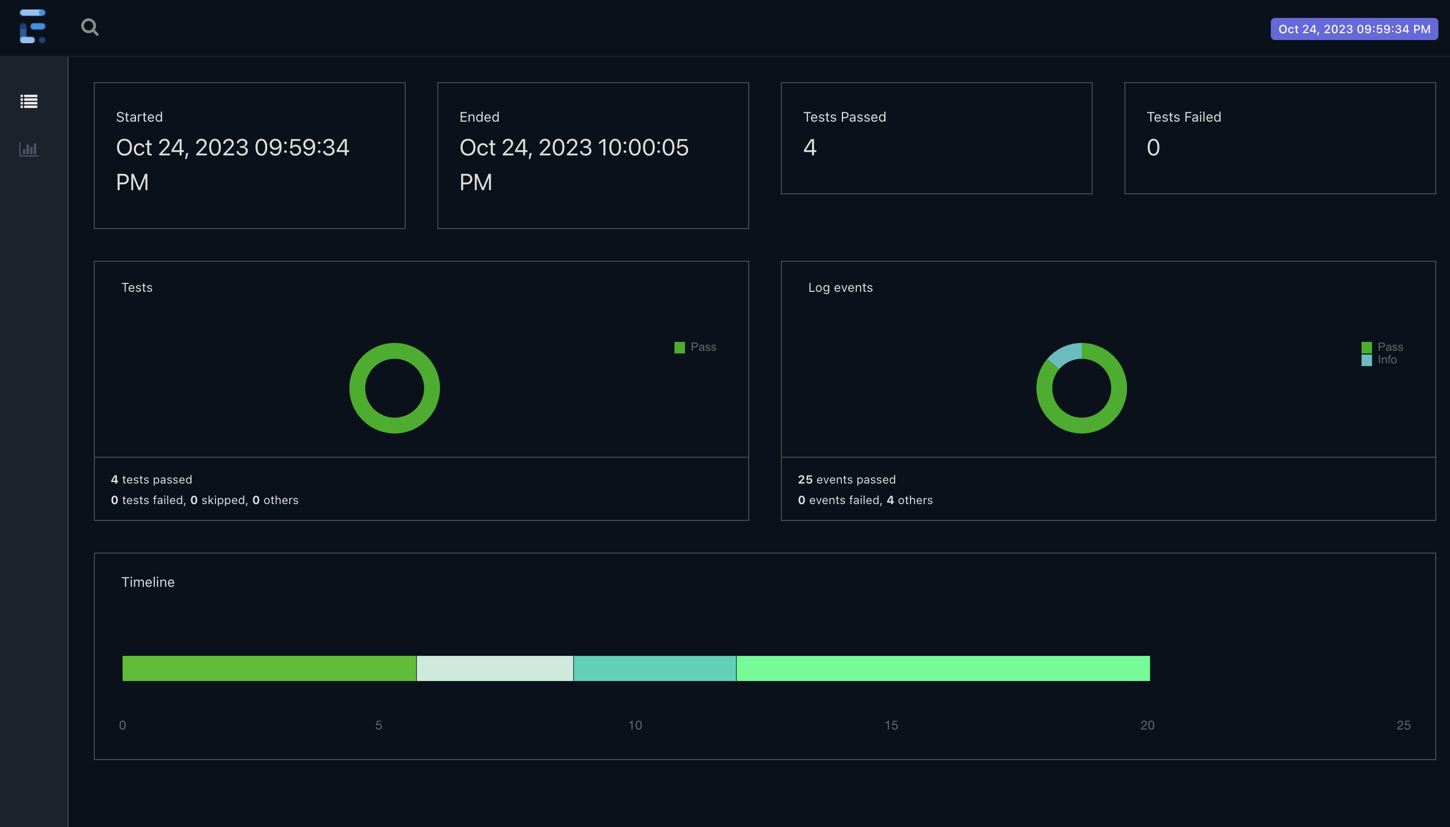

**Functionality 2: Create and Manage Board**

***Test 5: Verify that user can create board with required information. (Board Creation Happy Path)***

Board Creation with all attributes required.

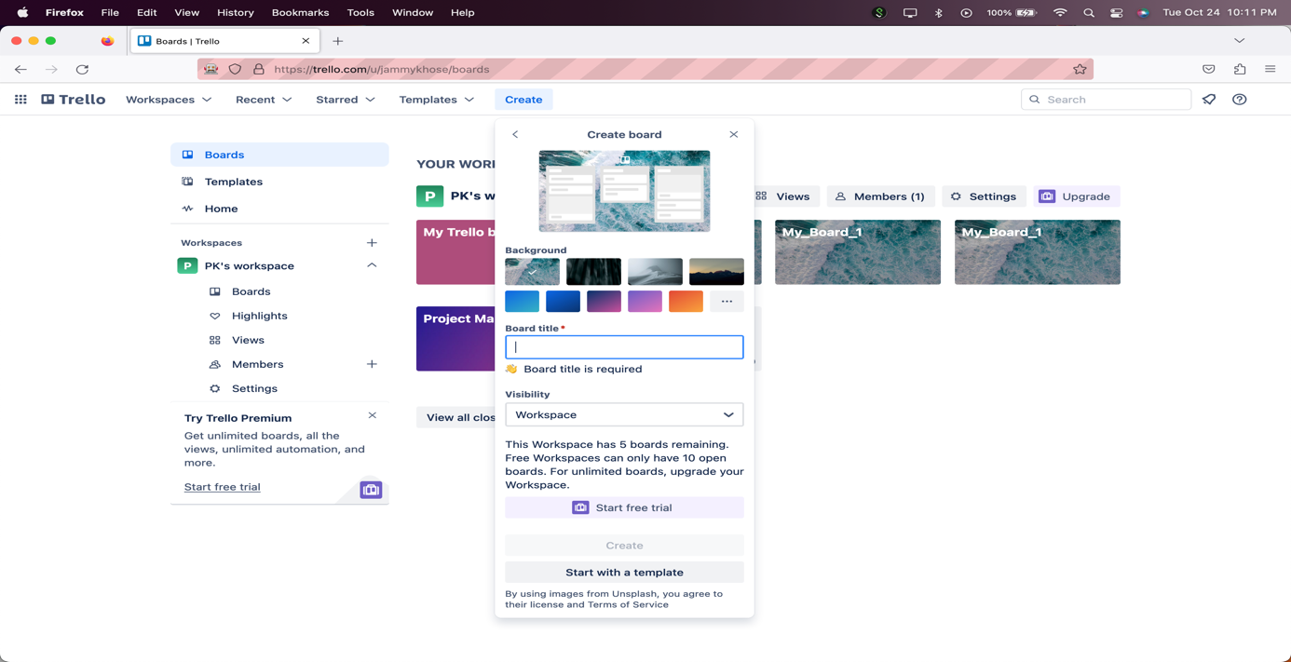

All value entered and then clicked on create board button.

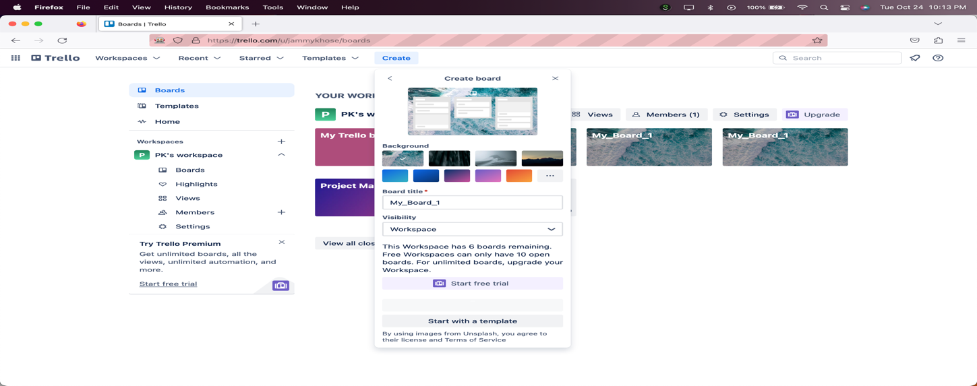

Created Board.

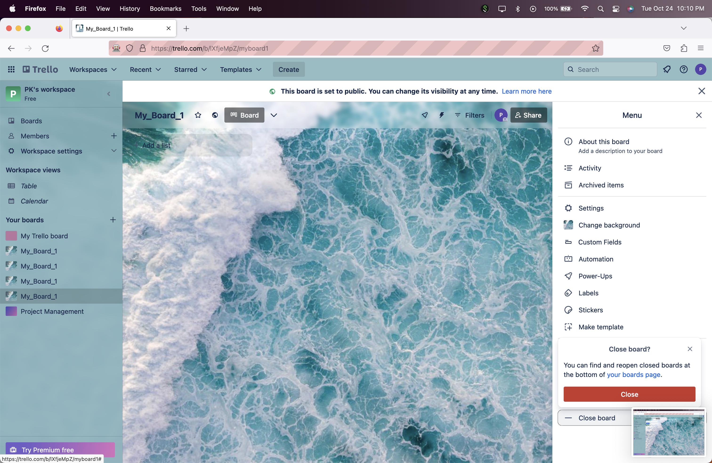

Test 5: Report

**Test 5 status: Pass**

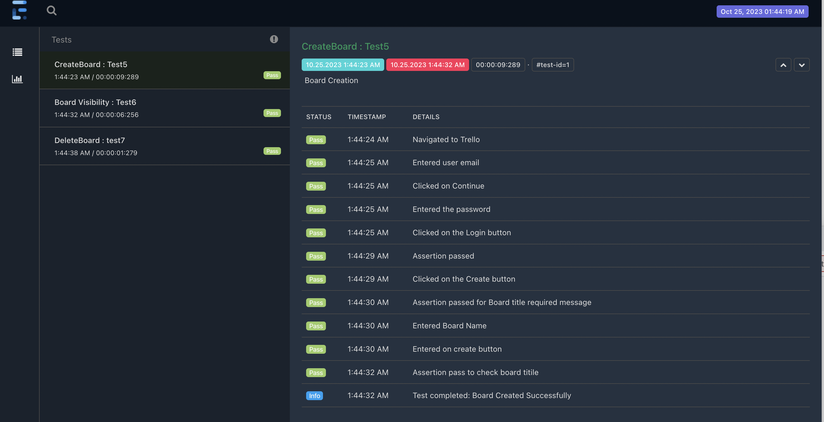

***Test 6: Verify that user can change board visibility.***

Clicked on visibility icon and then changed the privacy

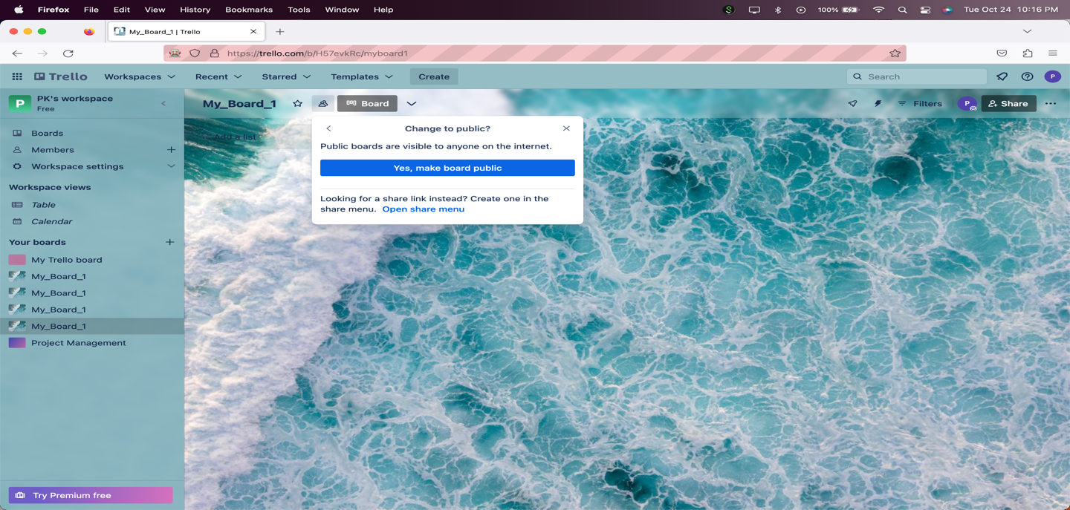

Visibility message asserted and verified.



**Test 6: Report**

**Test 6 Status: Pass**

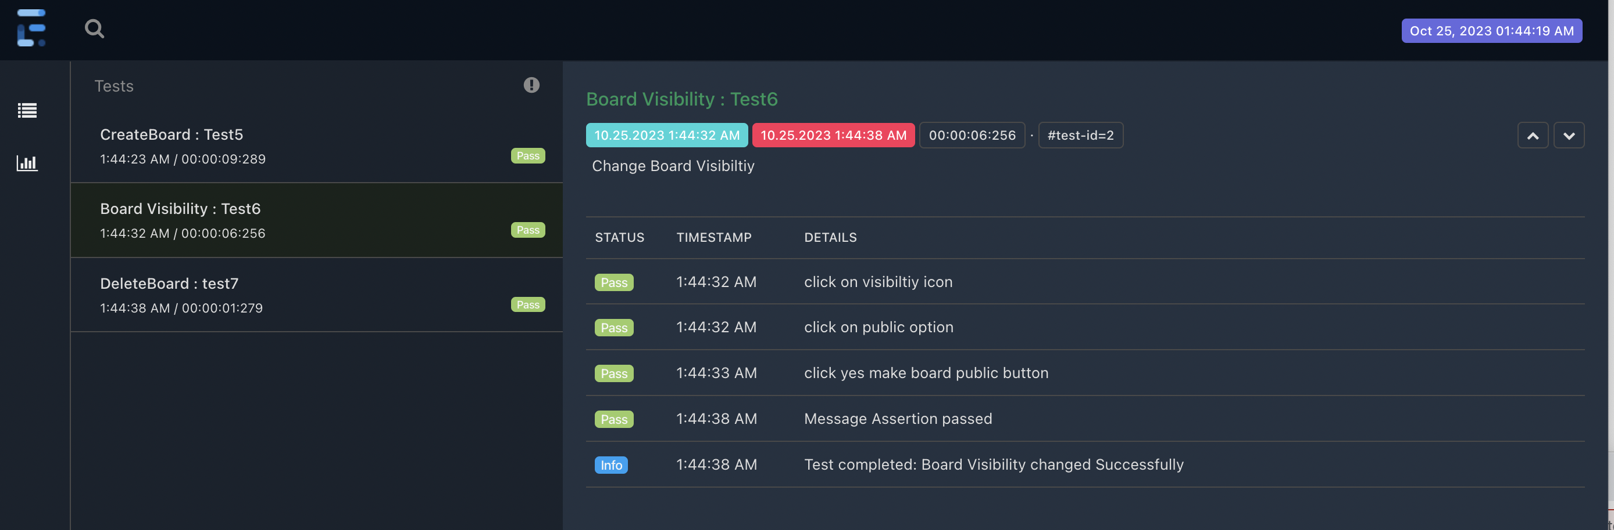

***Test 7: Verify that user can delete the board. (Board Deletion).***

Clicked on close board button from profile.



Clicked on permanently delete board link and then delete button.

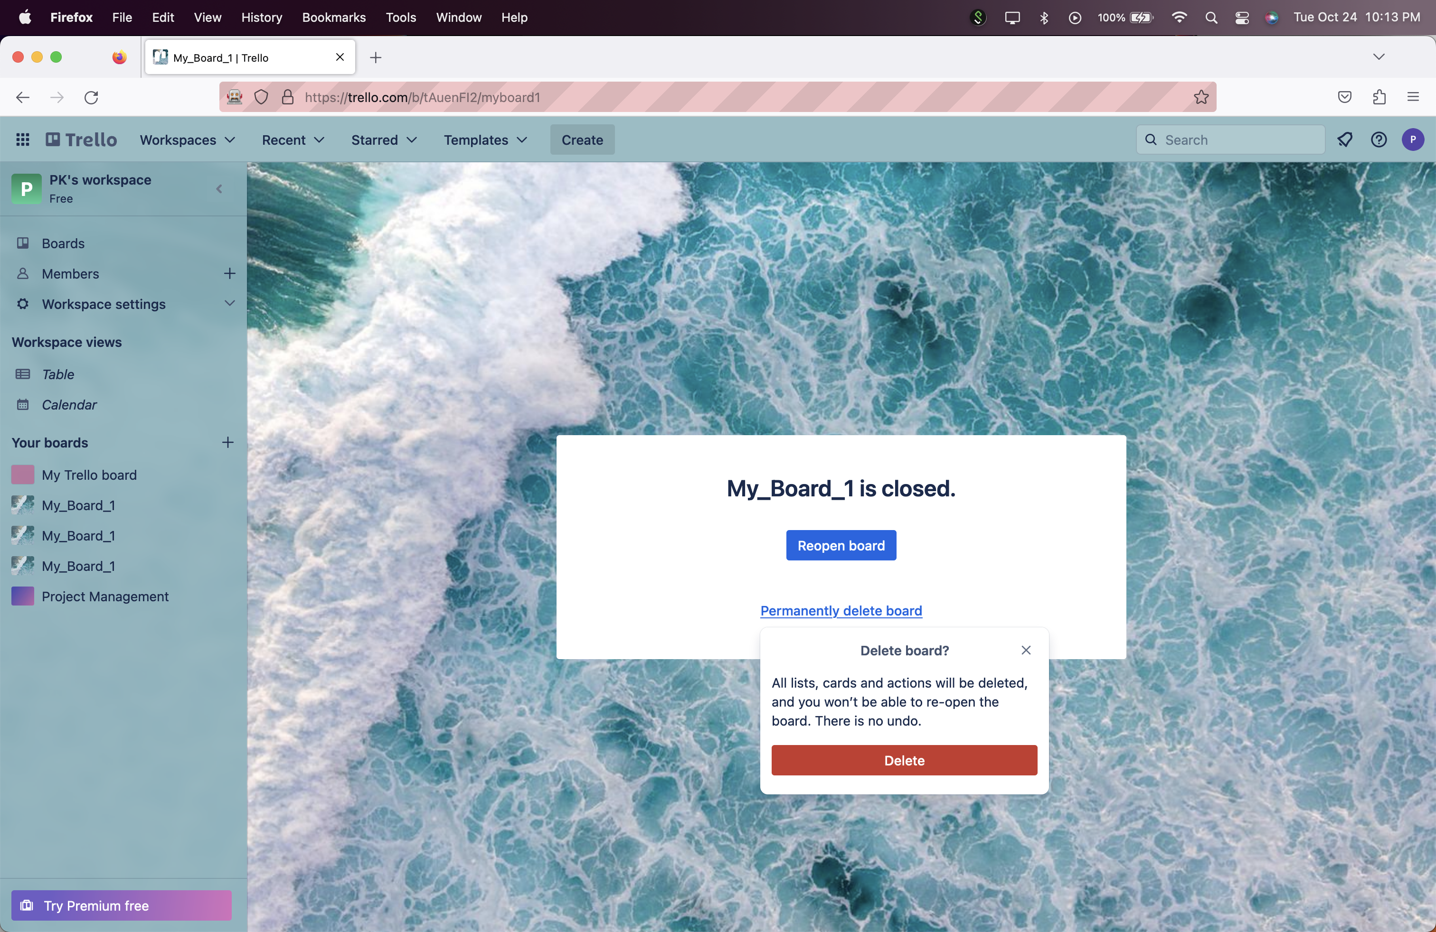

Board Deleted.

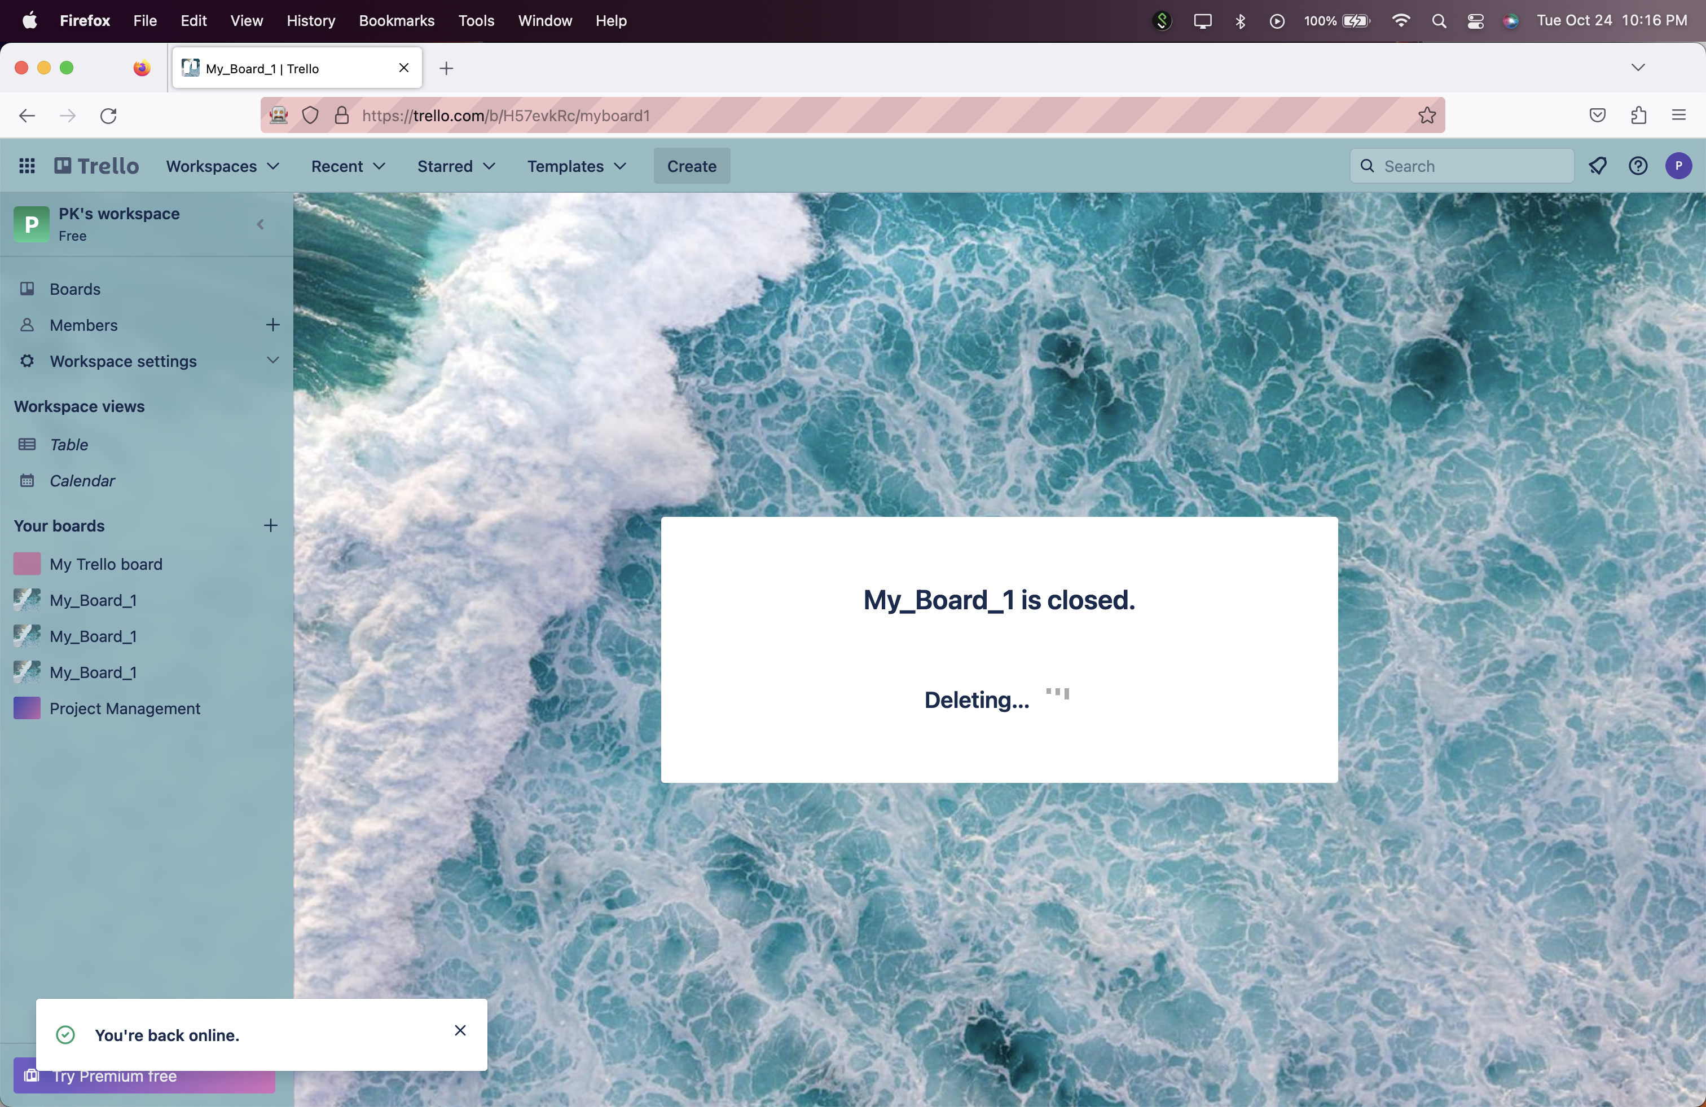

**Test 7: Report**

**Test 7 Status: Pass**

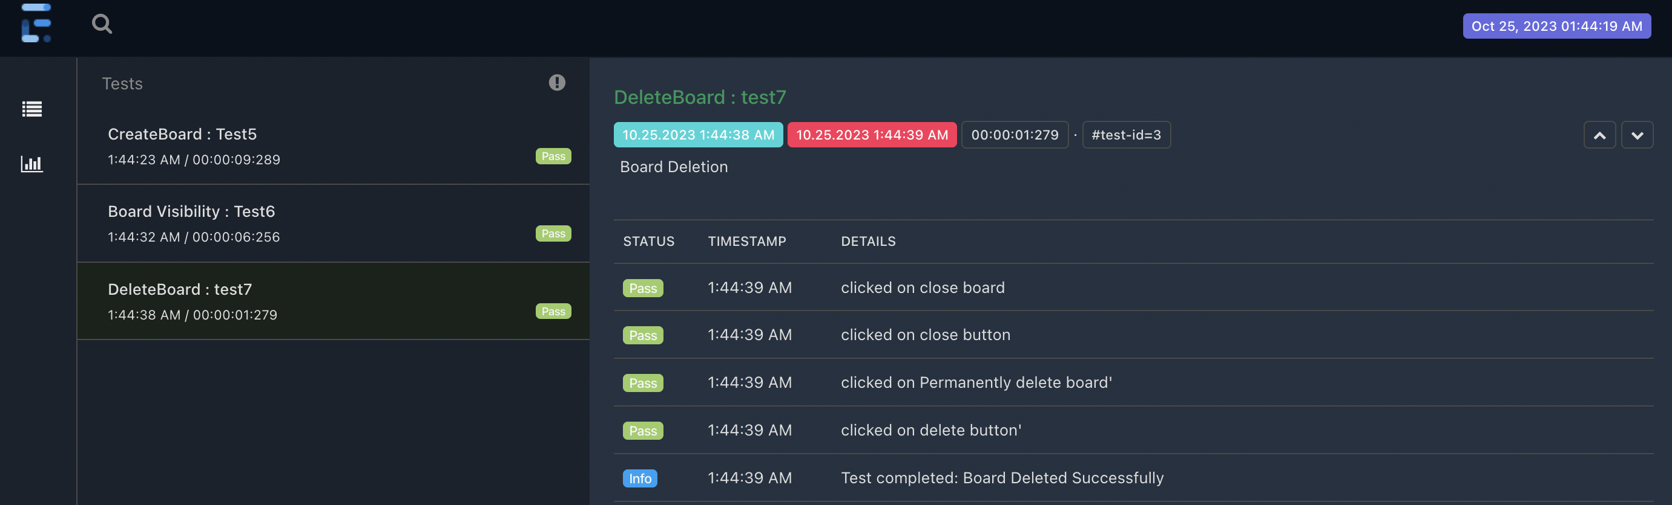

**BoardTests Test Suite Report**

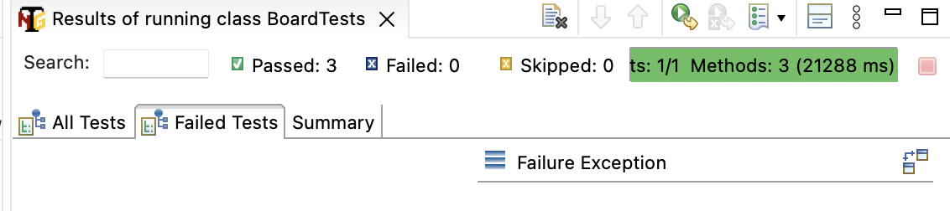

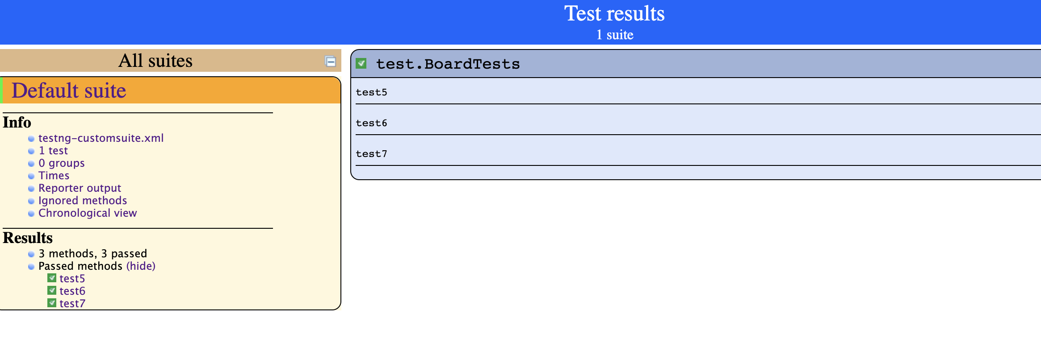

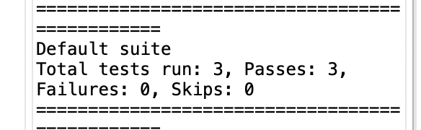

All test cases from Create and Manage Board functionality are passed.

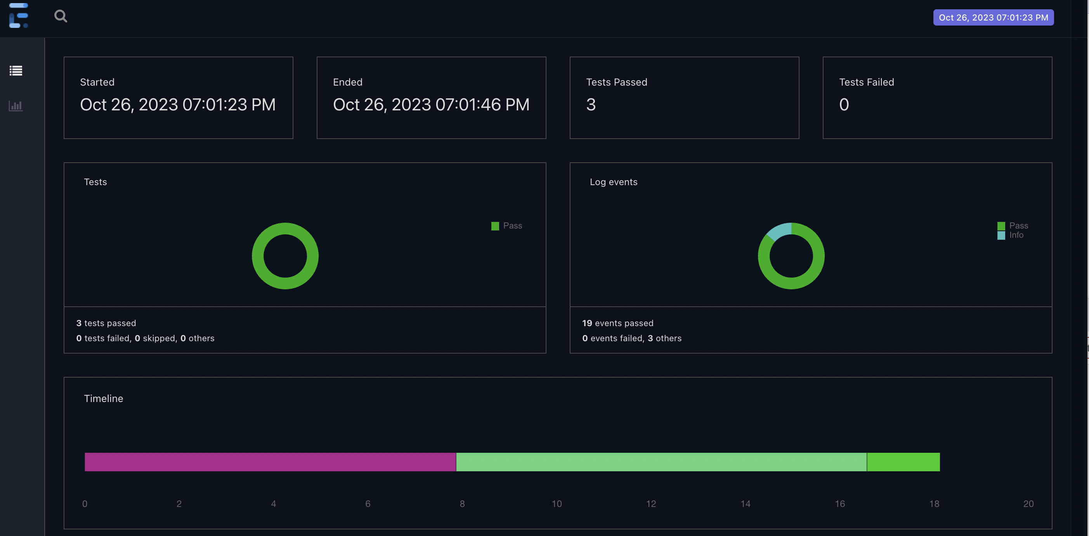

**Functionality 3: Sign Up**

***Test 8: Verify that user cannot sign up with blank email Id.***

Got an error message to enter an email address. Message assertion passed

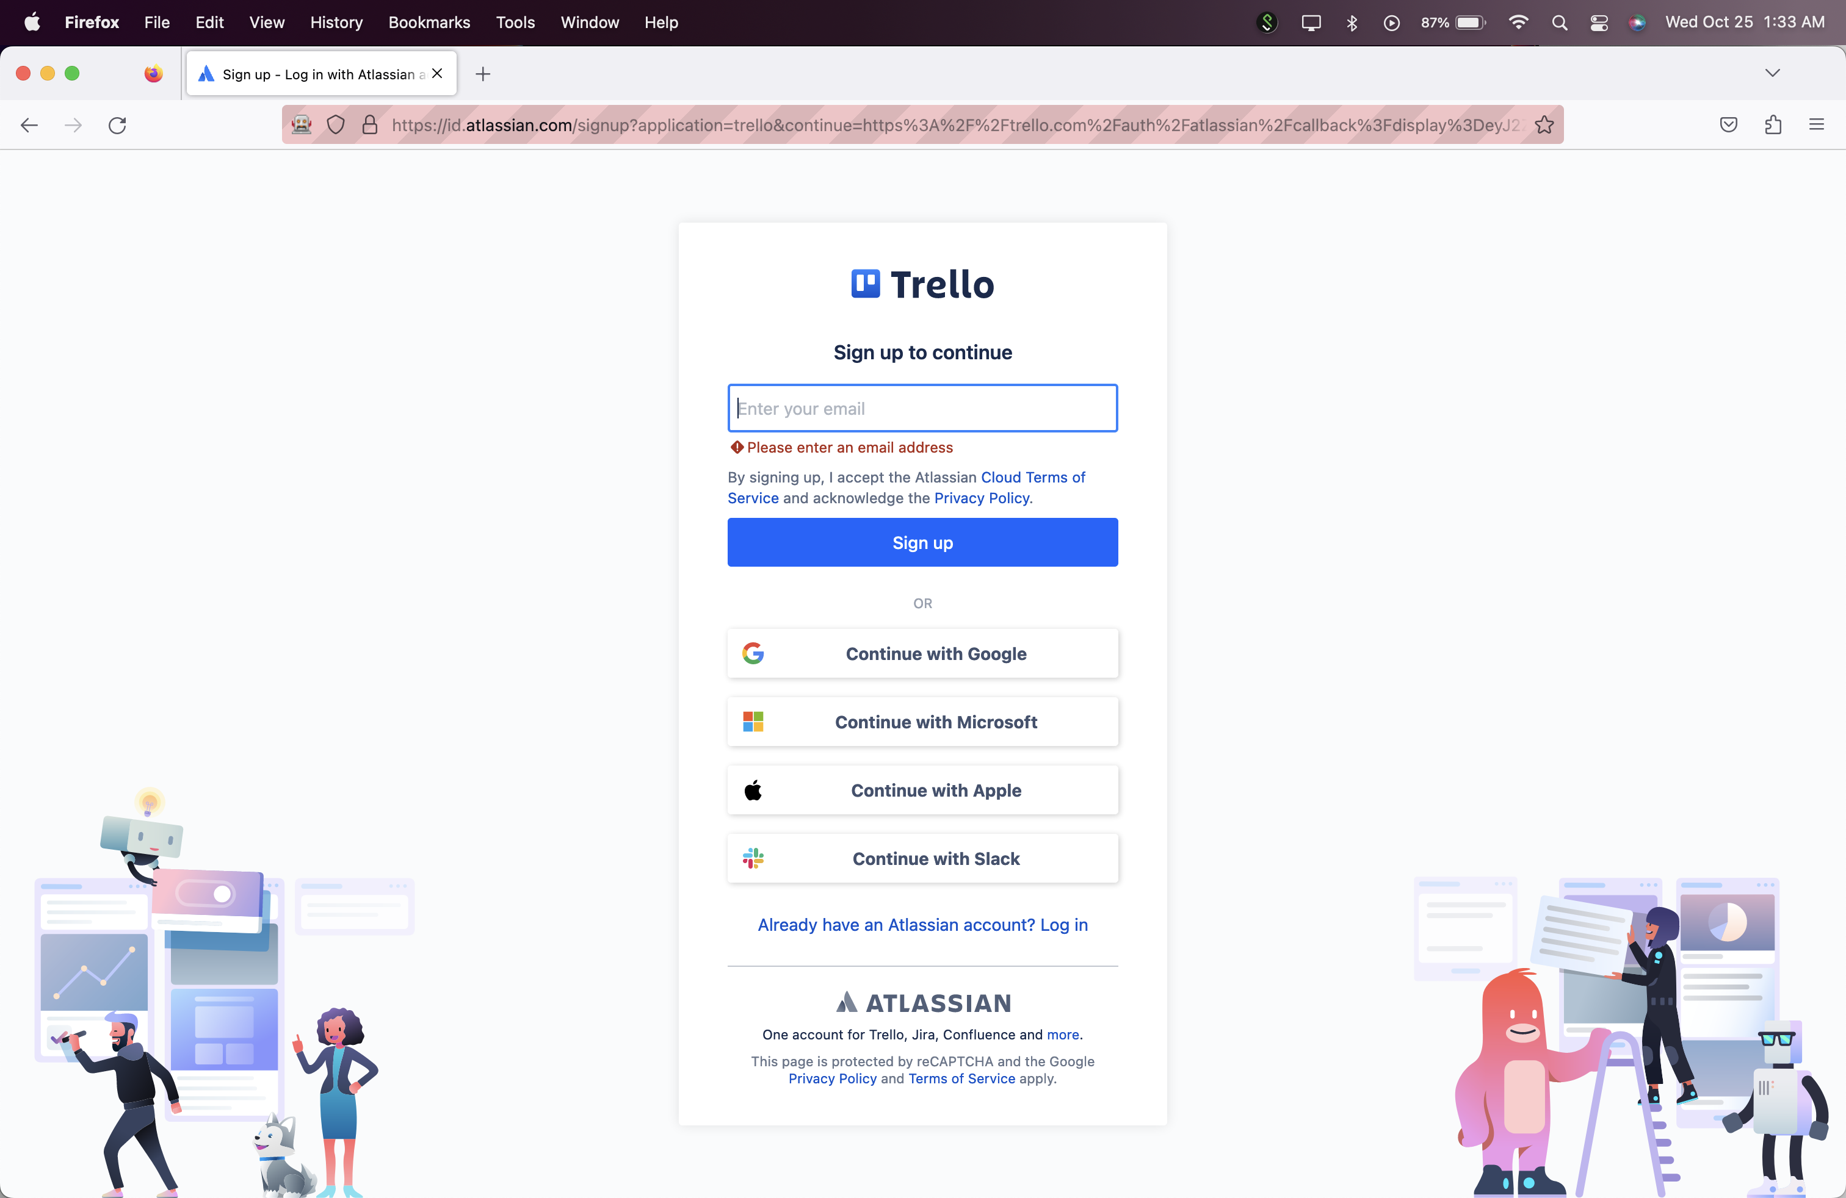

**Test 8: Report**

**Test 8 Status: Pass**

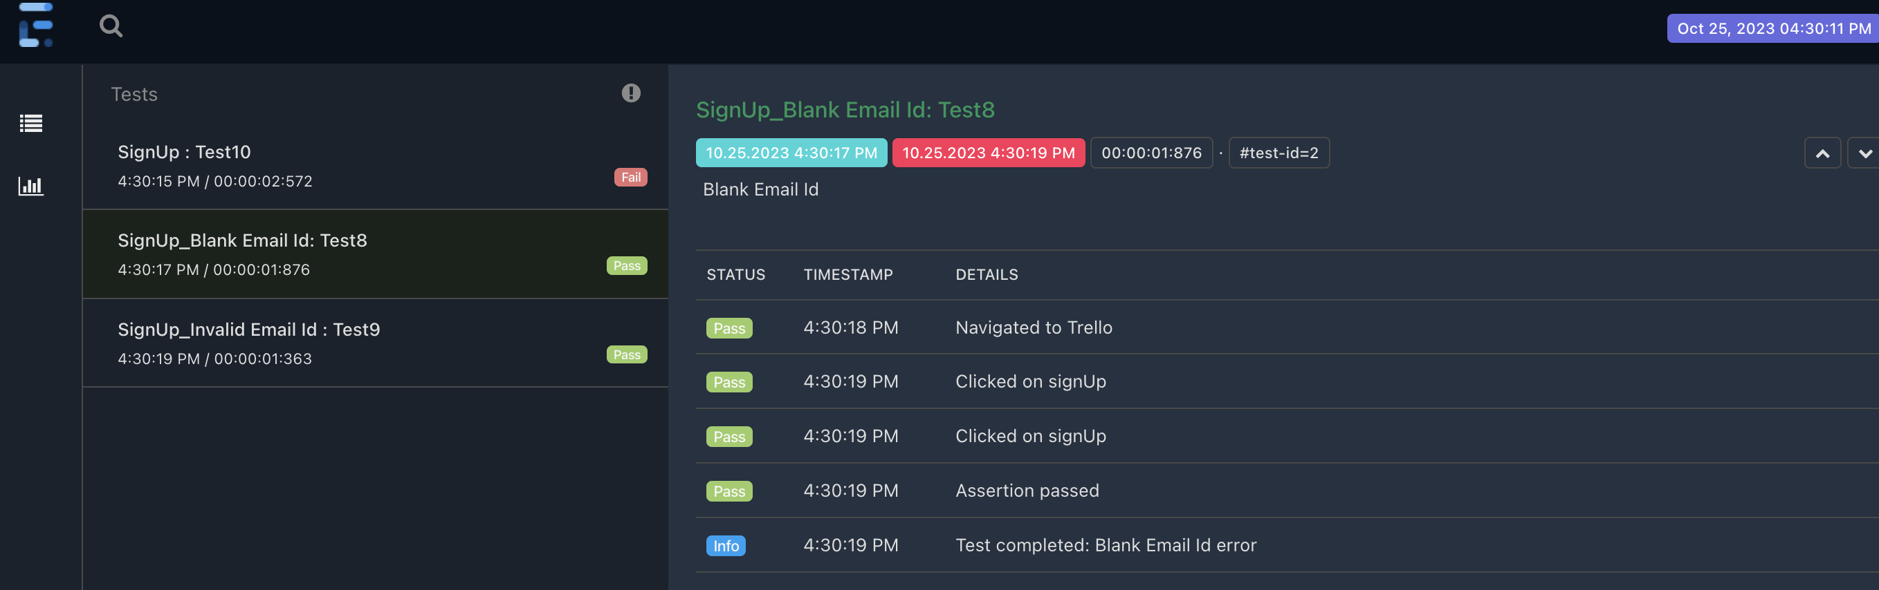

***Test 9: Verify that user cannot sign up with invalid email Id.***

Got an error message. Message assertion passed.

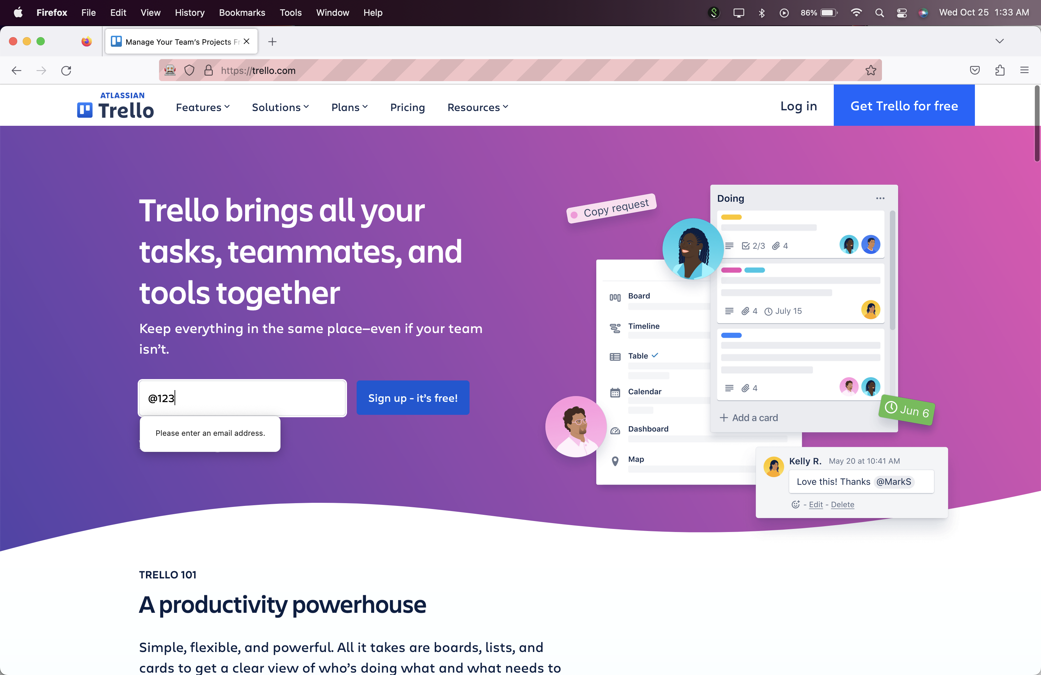

**Test 9: Report**

**Test 9 Status: Pass**

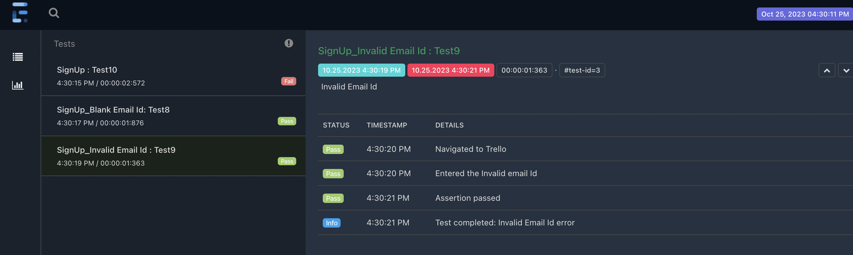

***Test 10: Verify that user can sign up with valid email Id. (Sign Up Happy path)***

Entered valid email to sign up.

After clicking on sign up button got Captcha on the next page.

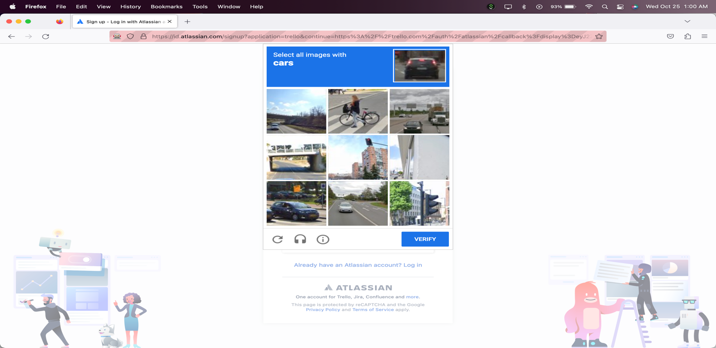

Test 10: Report

Test 10 status: Fail

Failure Description:

As per,<https://www.selenium.dev/documentation/test_practices/discouraged/captchas/>

It is not recommended to automate Captcha. Hence failing test case here as we can’t test further.

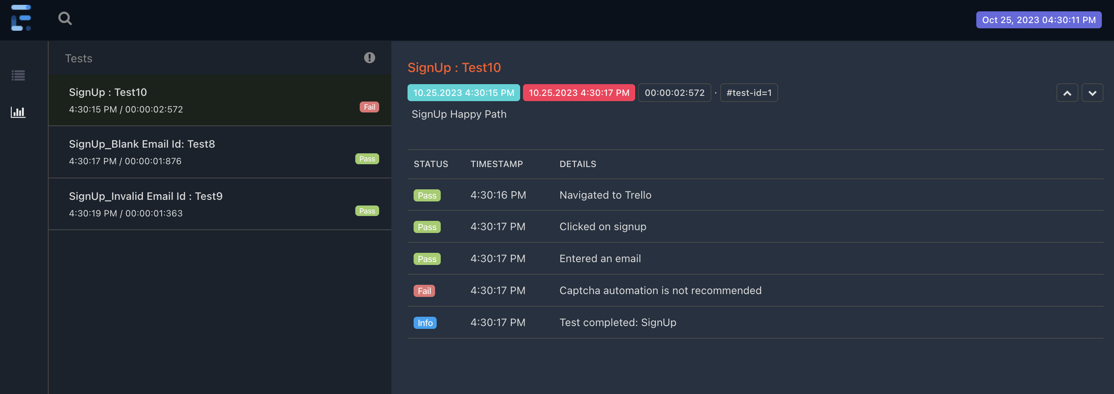

Trello SignUpTests suite status:

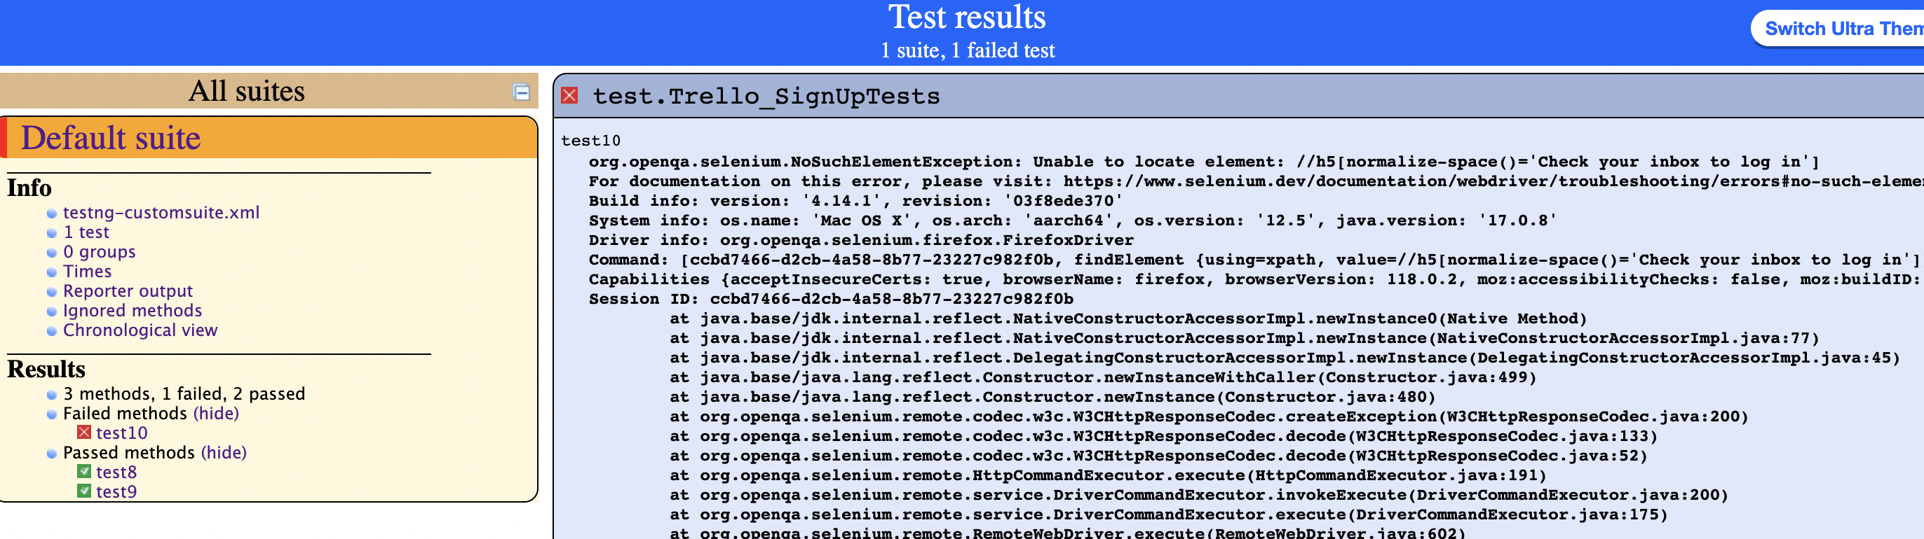

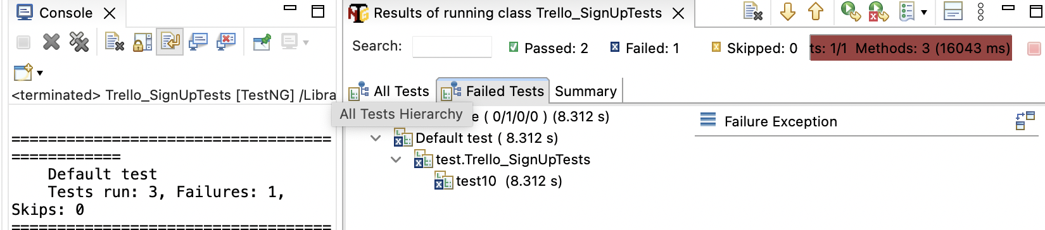

**Trello SignUpTests suite status**:

2 tests are passed

1 test is failed.

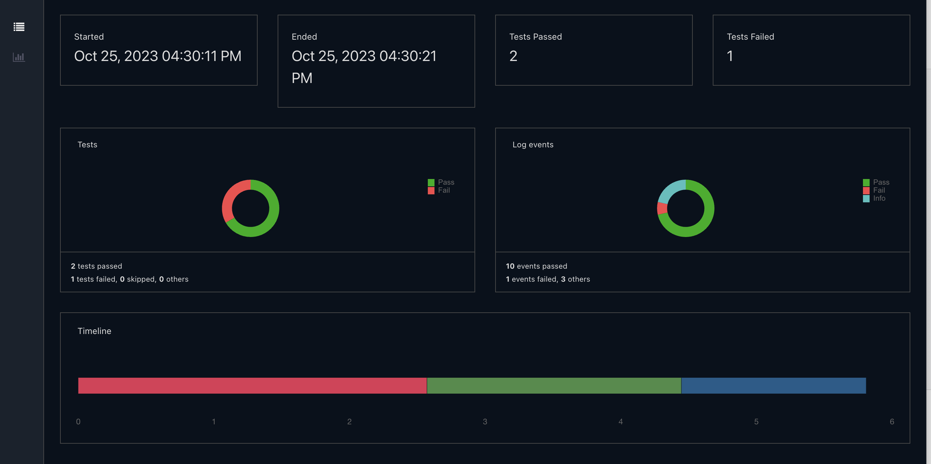

Functionality 4 : Create and Manage Lists and Cards

***Test 11: Verify that user can create list with card. (List and Card Creation Happy Path).***

Clicked on add a list and entered List name in existing board.

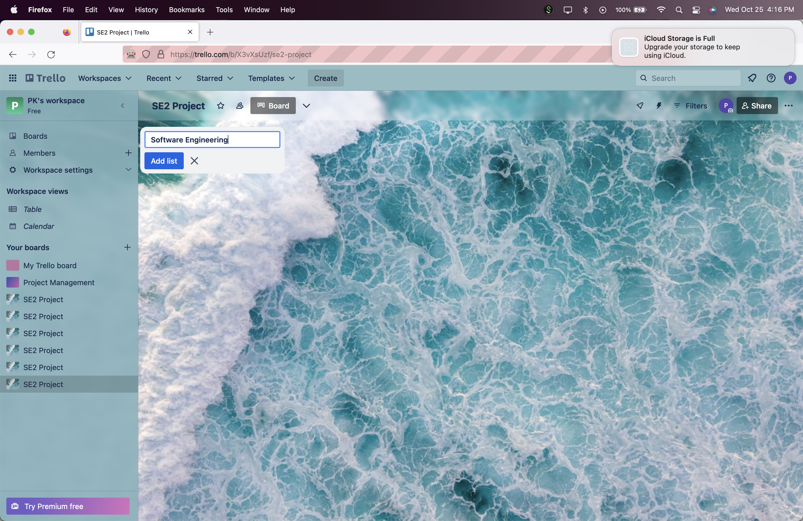

Clicked on Add a card button.

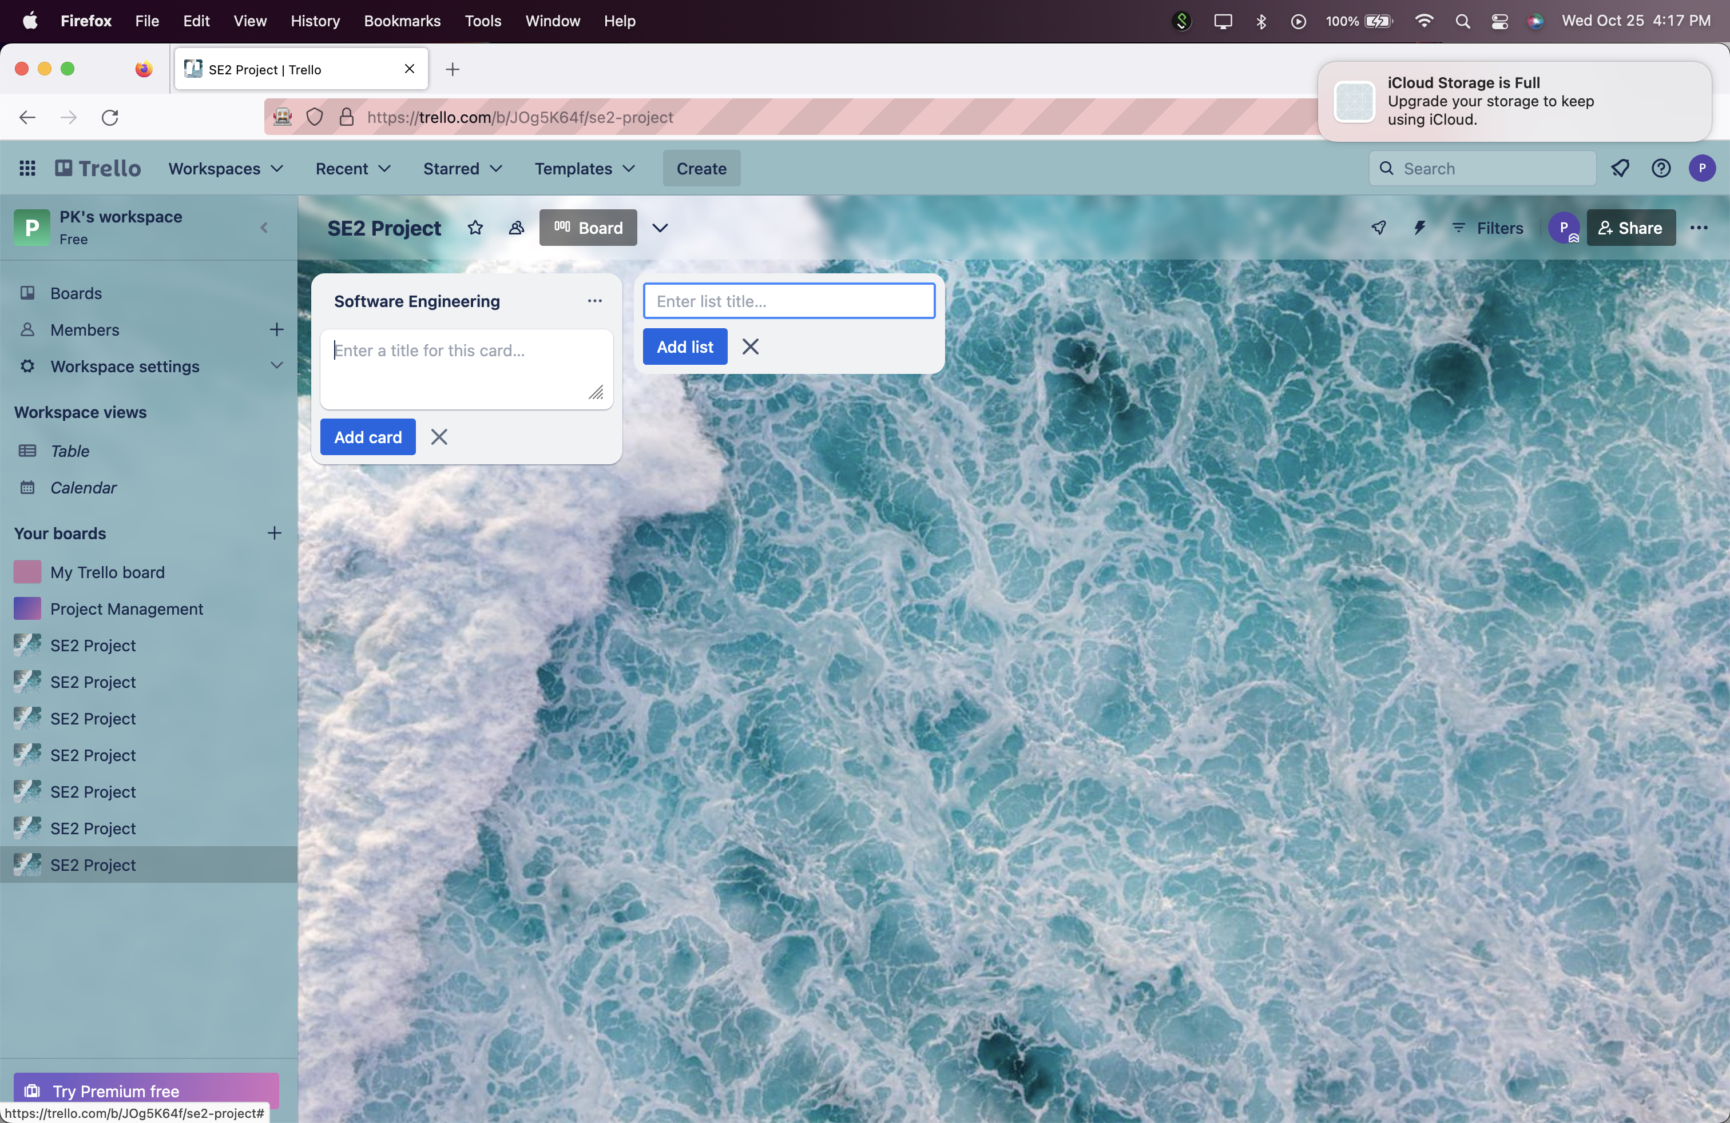

Entered card name.

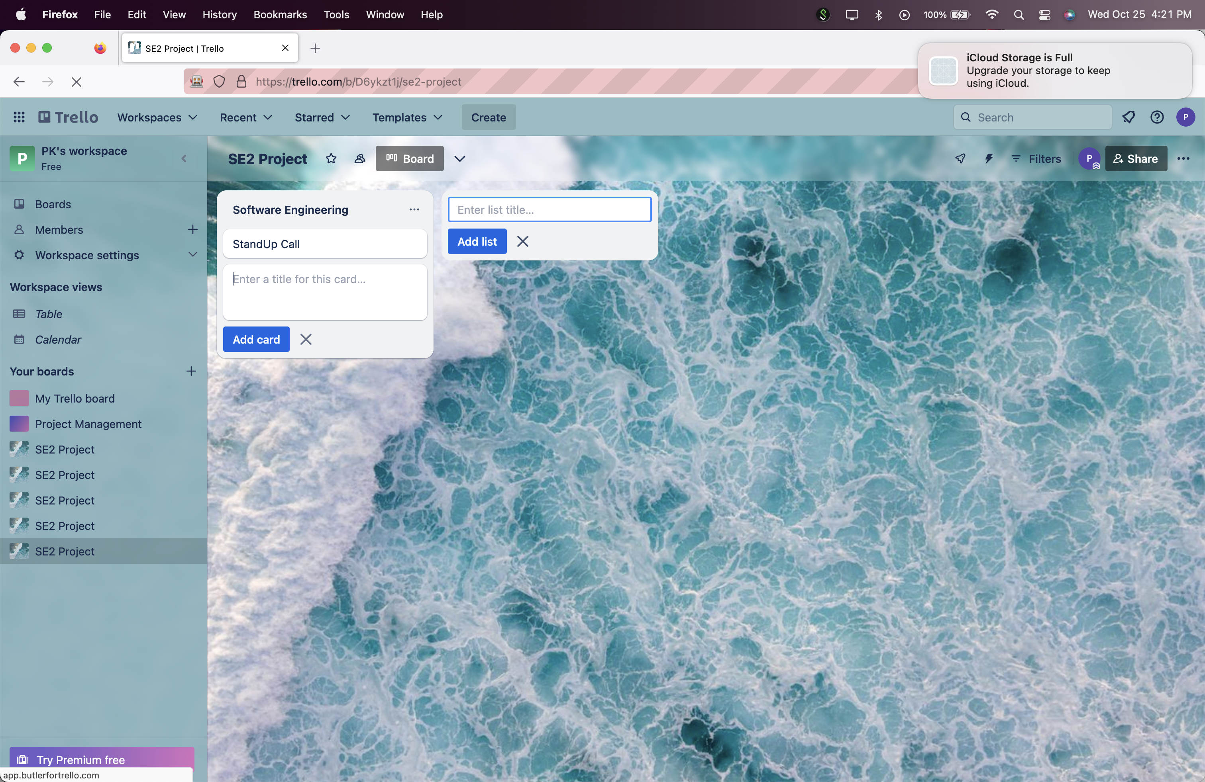

**Test 11 Report: Status Pass**

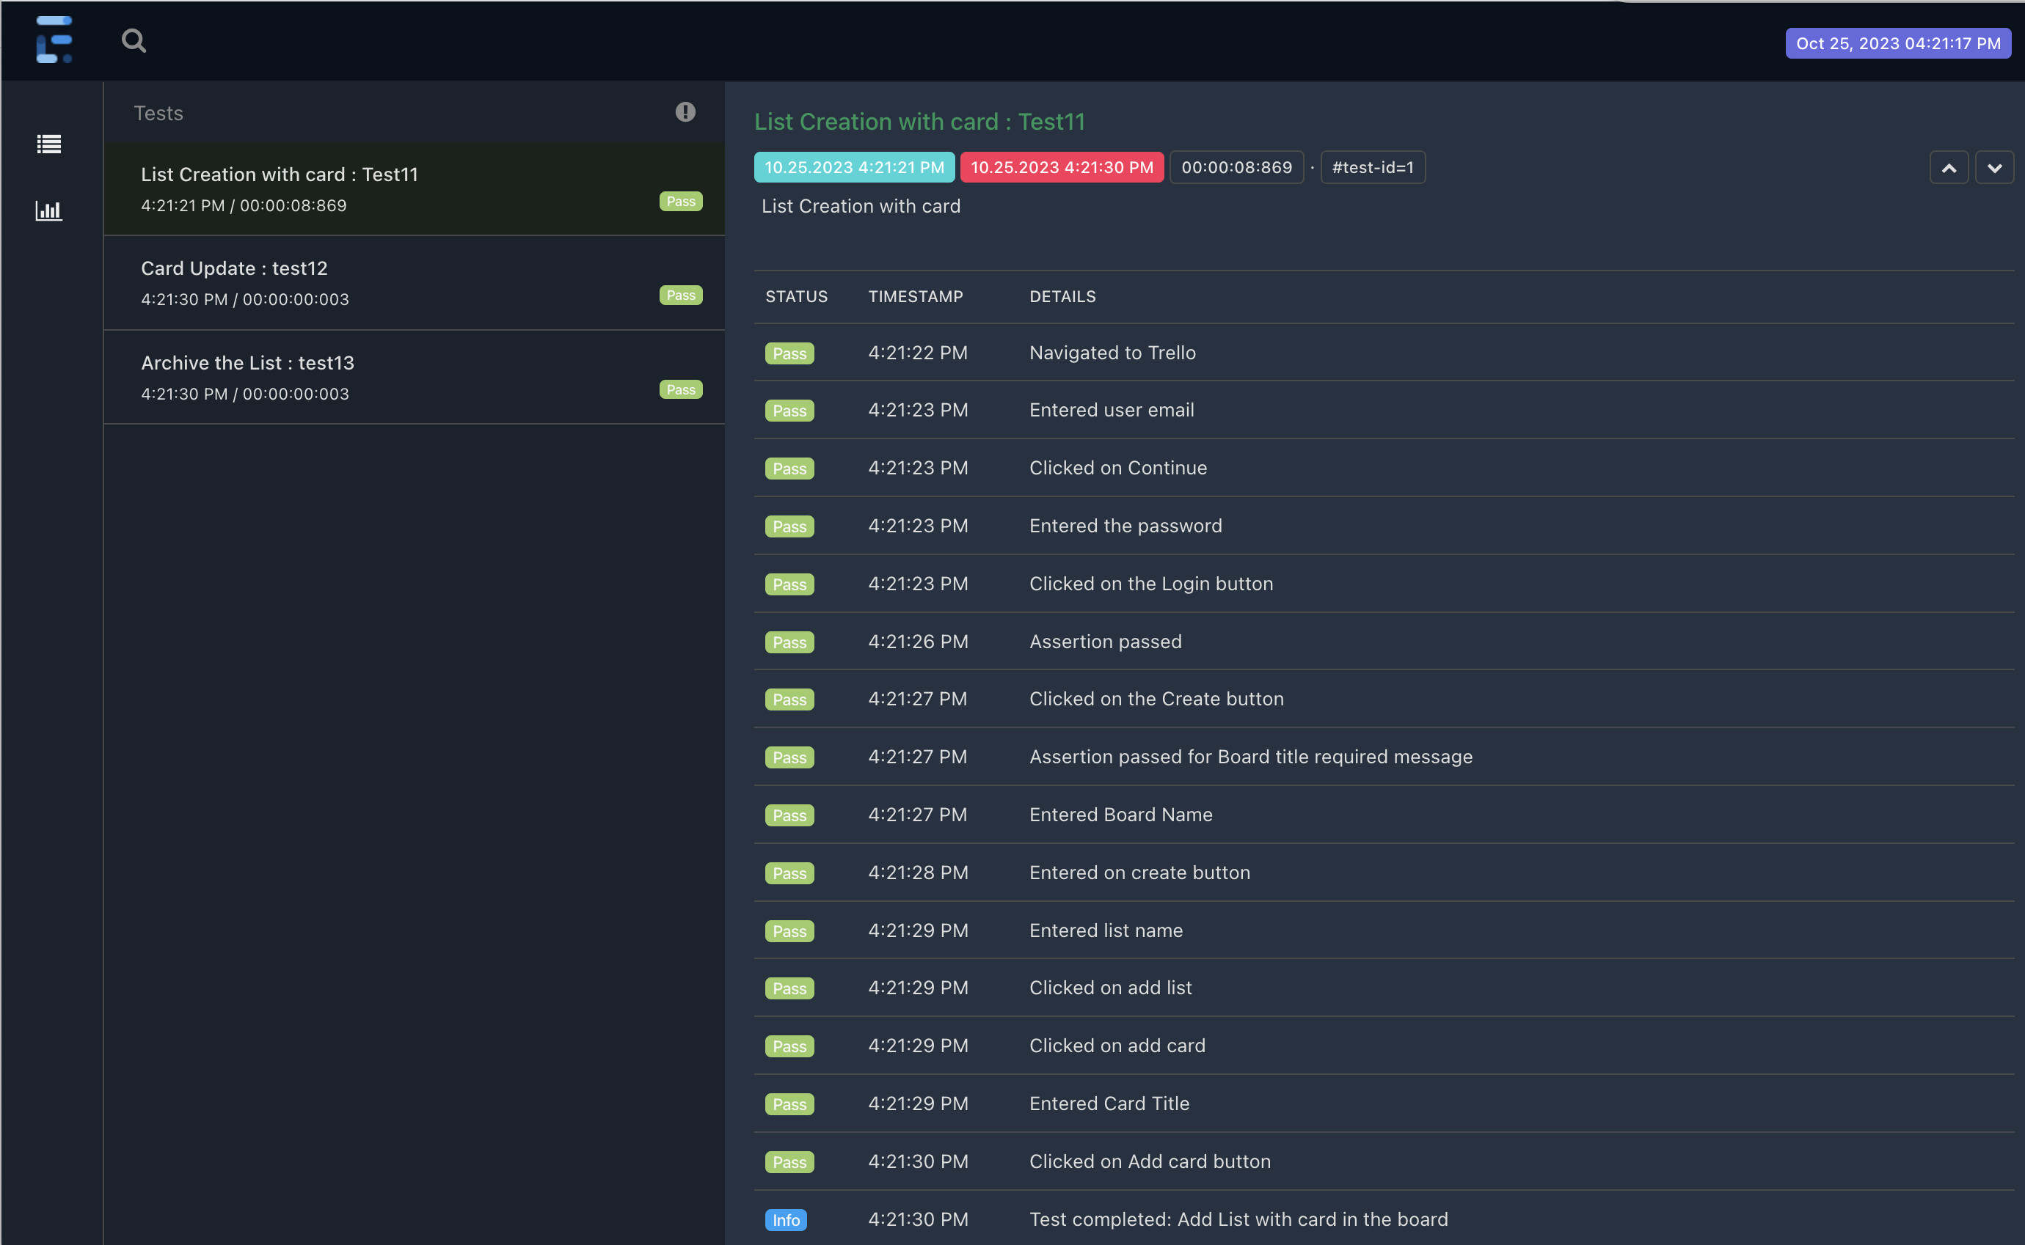

***Test 12: Verify that user can update the card with description details and comment.***

*Clicked on the card and then open card.*

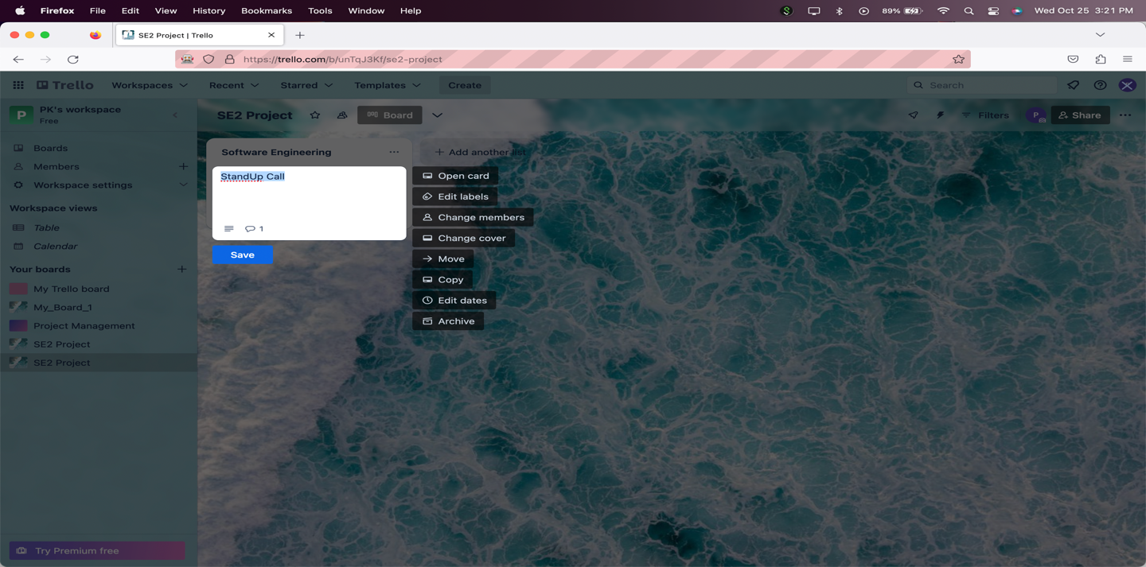

Added description

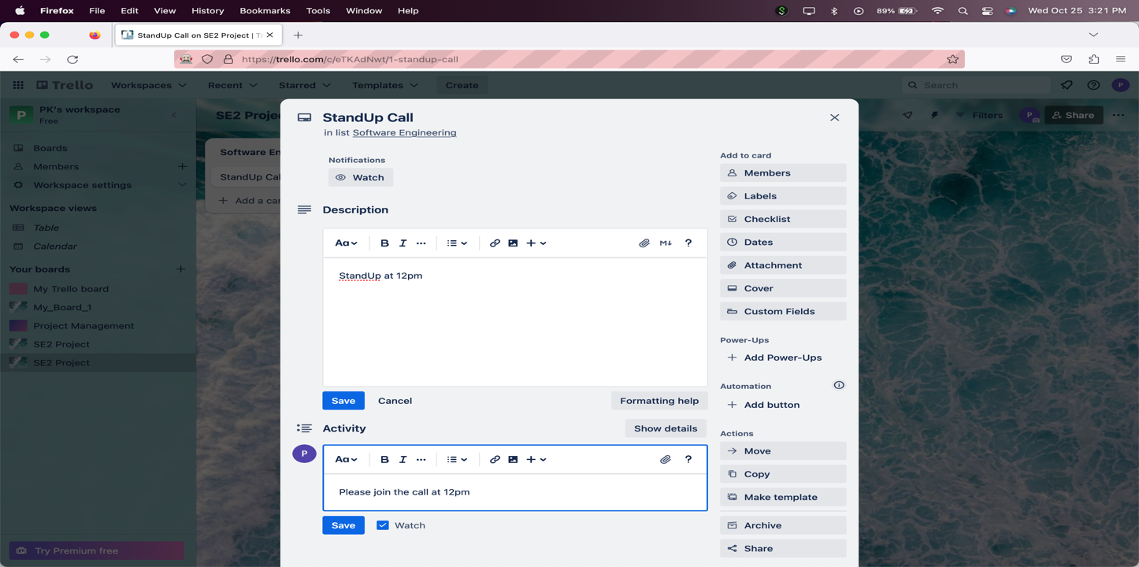

Added Comment.

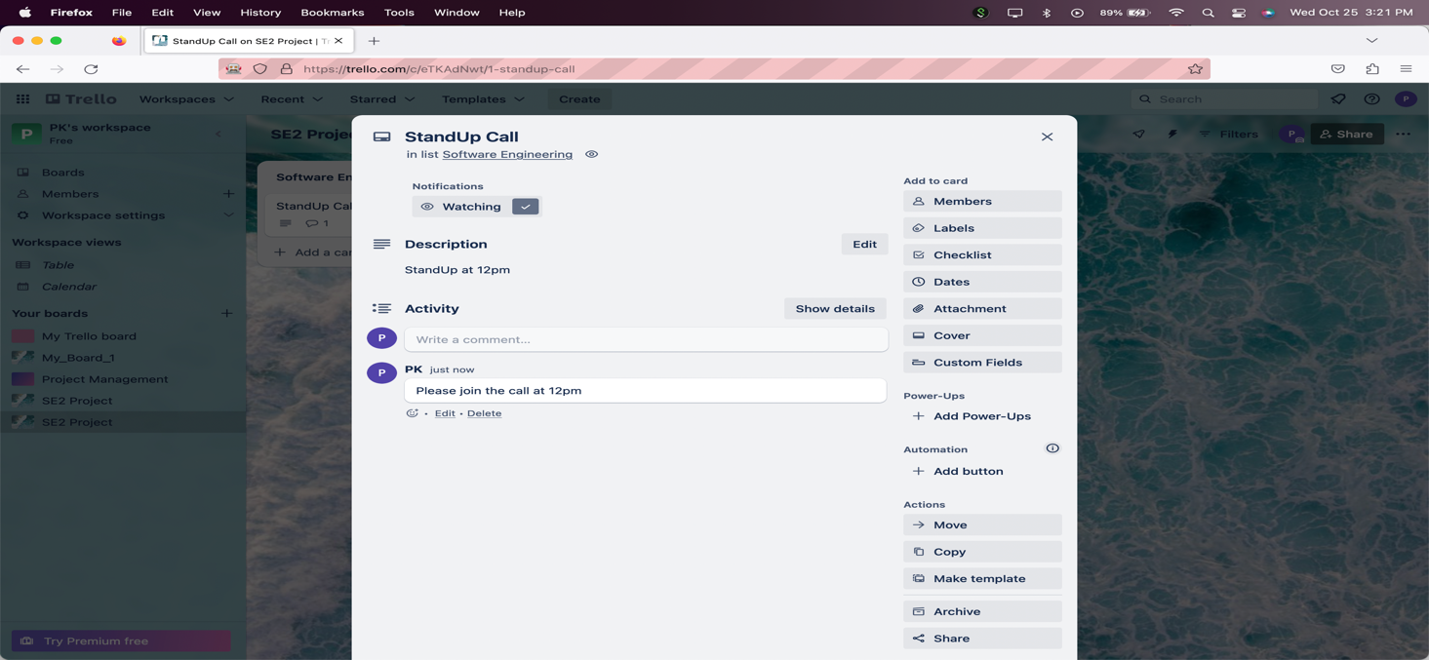

Card updated with comment and description.

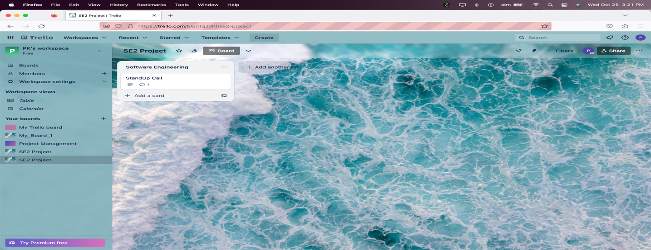

**Test 12: Report: Status: Pass**

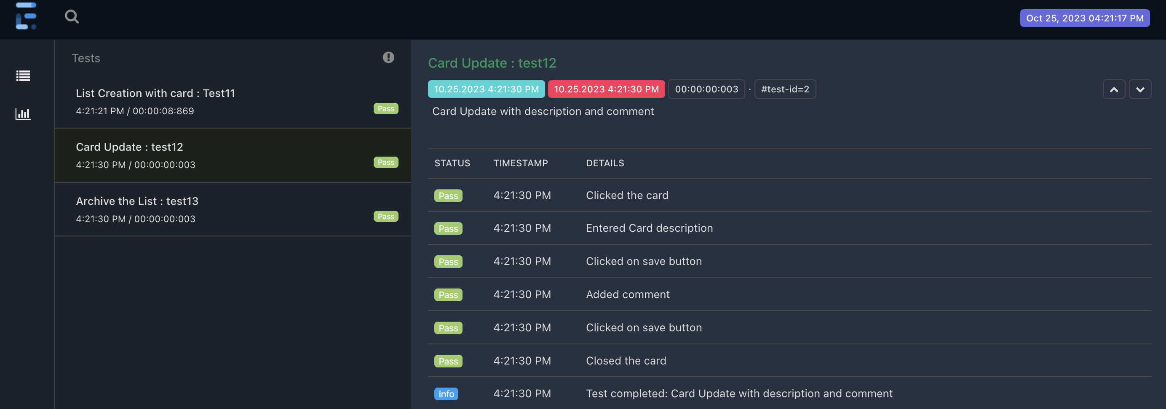

***Test 13: Verify that user can archive the selected list.***

*Clicked on list actions.*

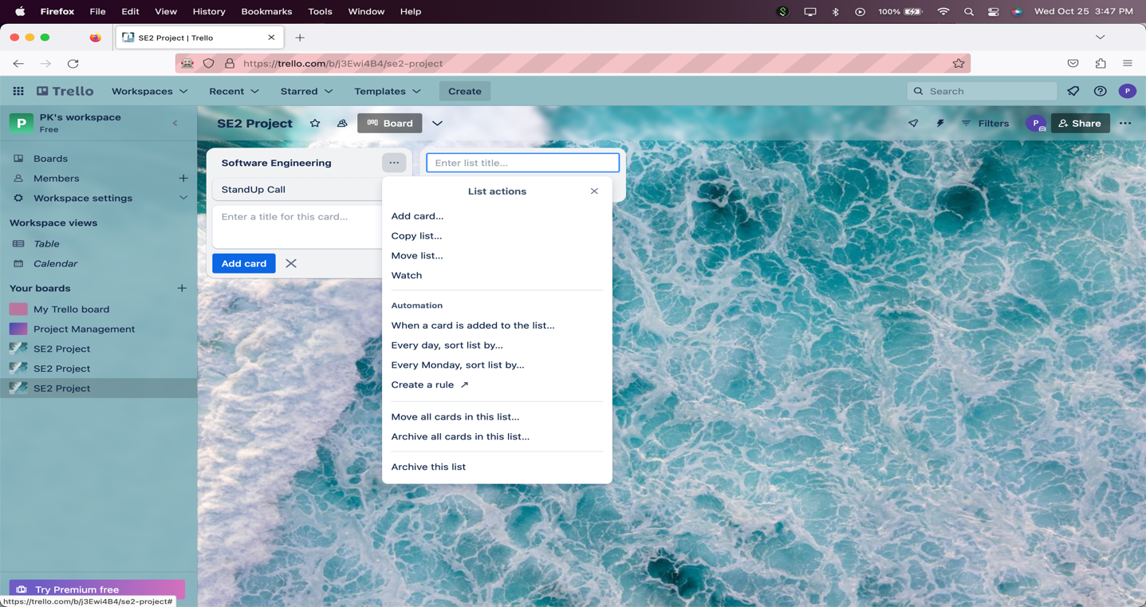

Clicked on Archive and list is archived.

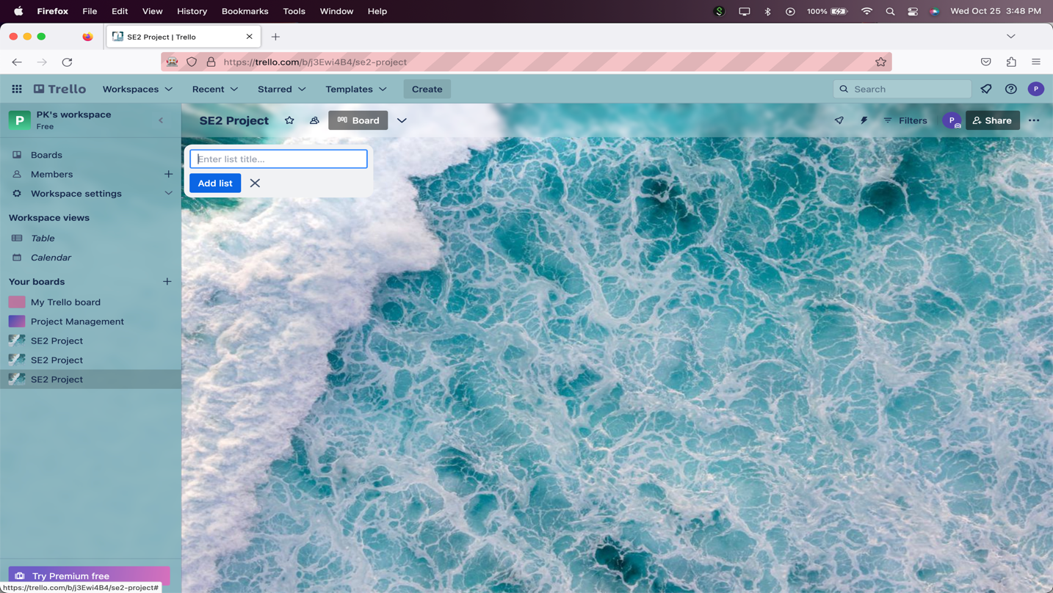

**Test 13: Report: Status: Pass**

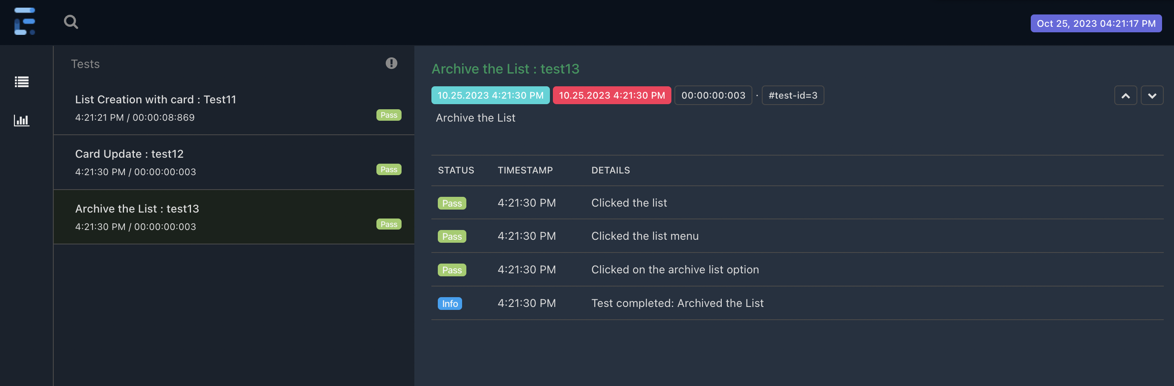

**All the test cases from CreateListTests suite are passed.**

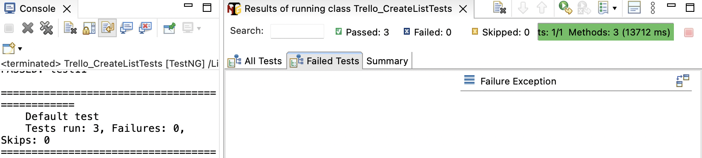

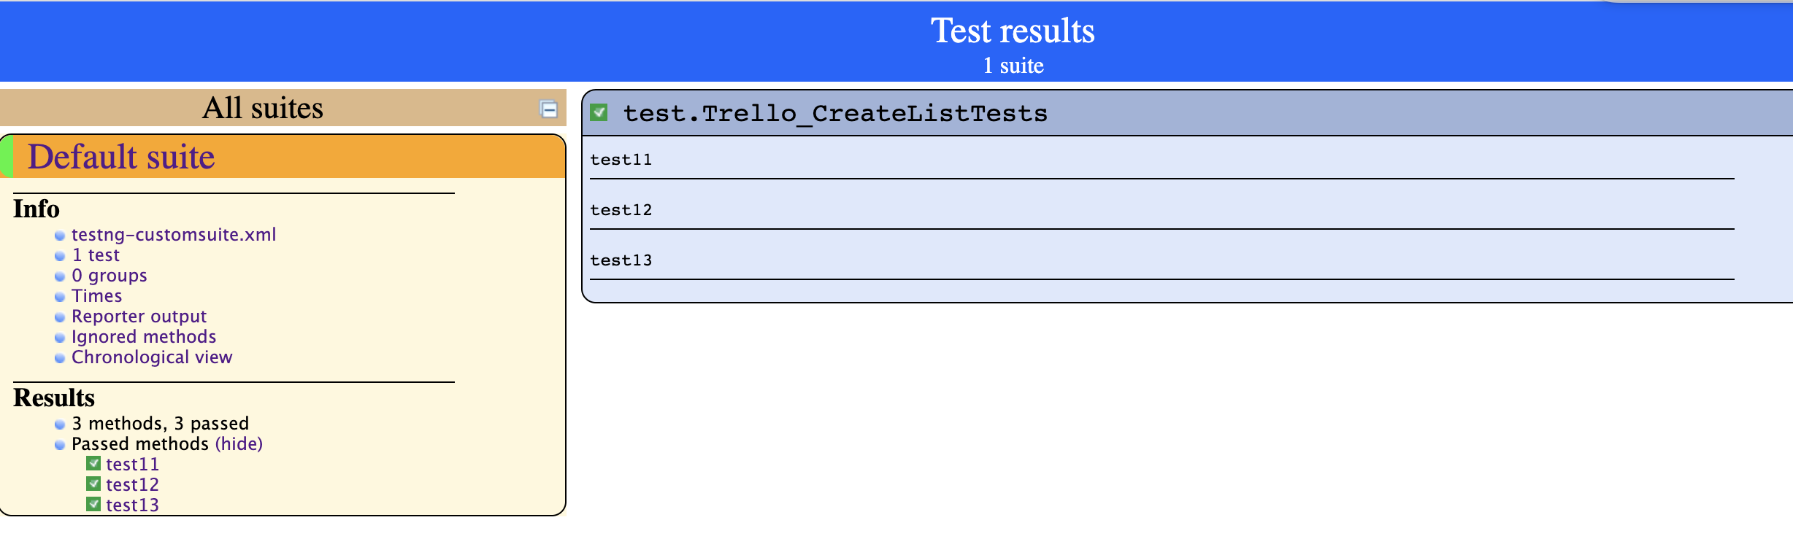

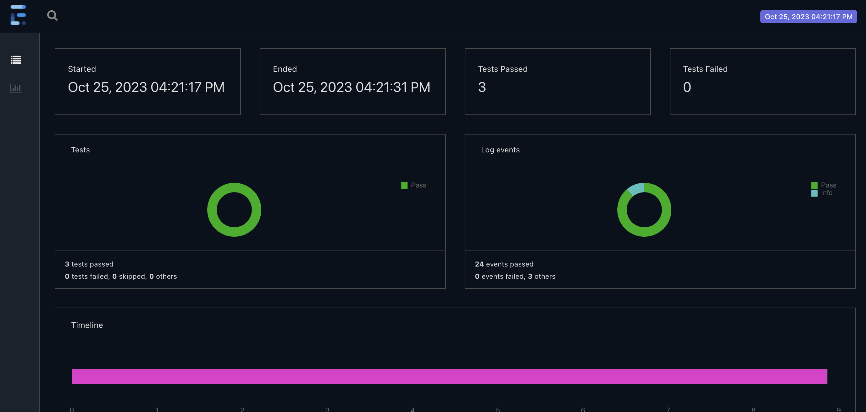

**Functionality 5: Create and Manage Workspace**

***Test 14: Verify that user can create workspace with required information. (Workspace Creation Happy Path)***

Entered workspace name and type and clicked on create button*.*

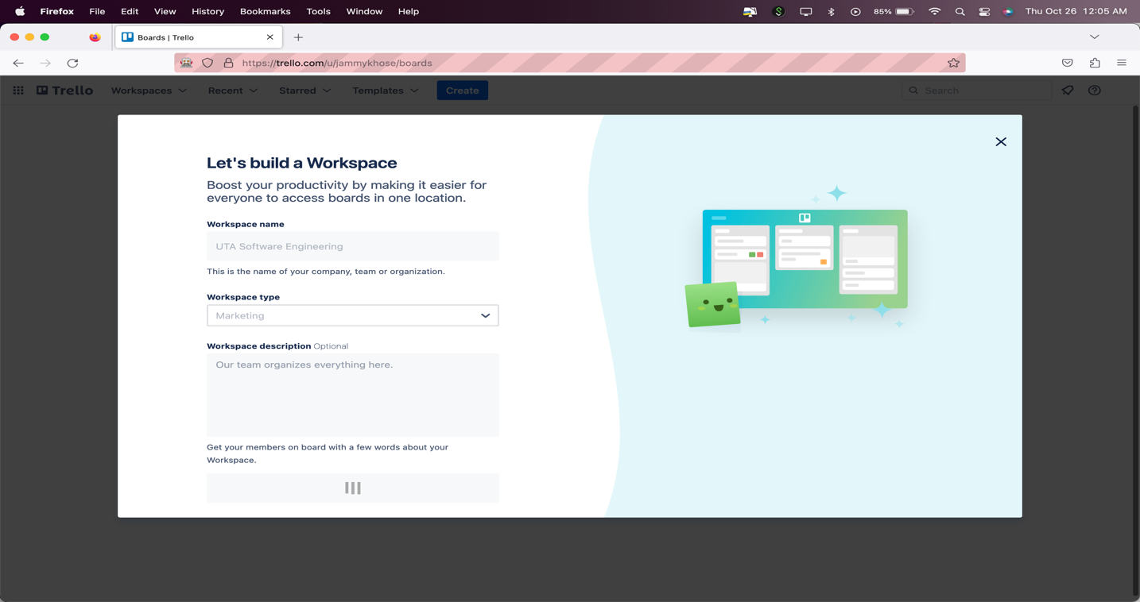

Workspace created.

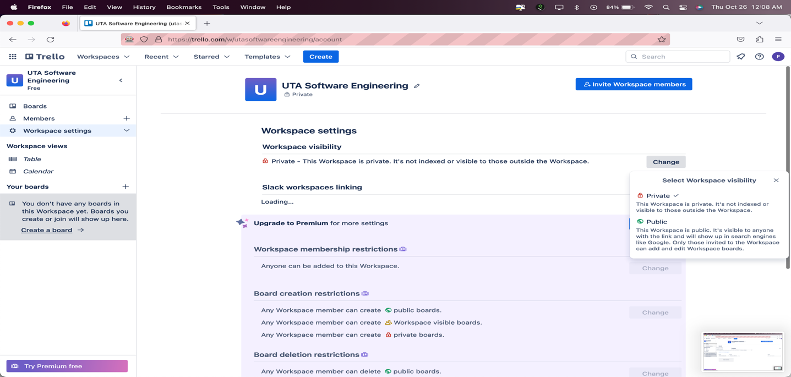

**Test 14: Report: Status: Pass**

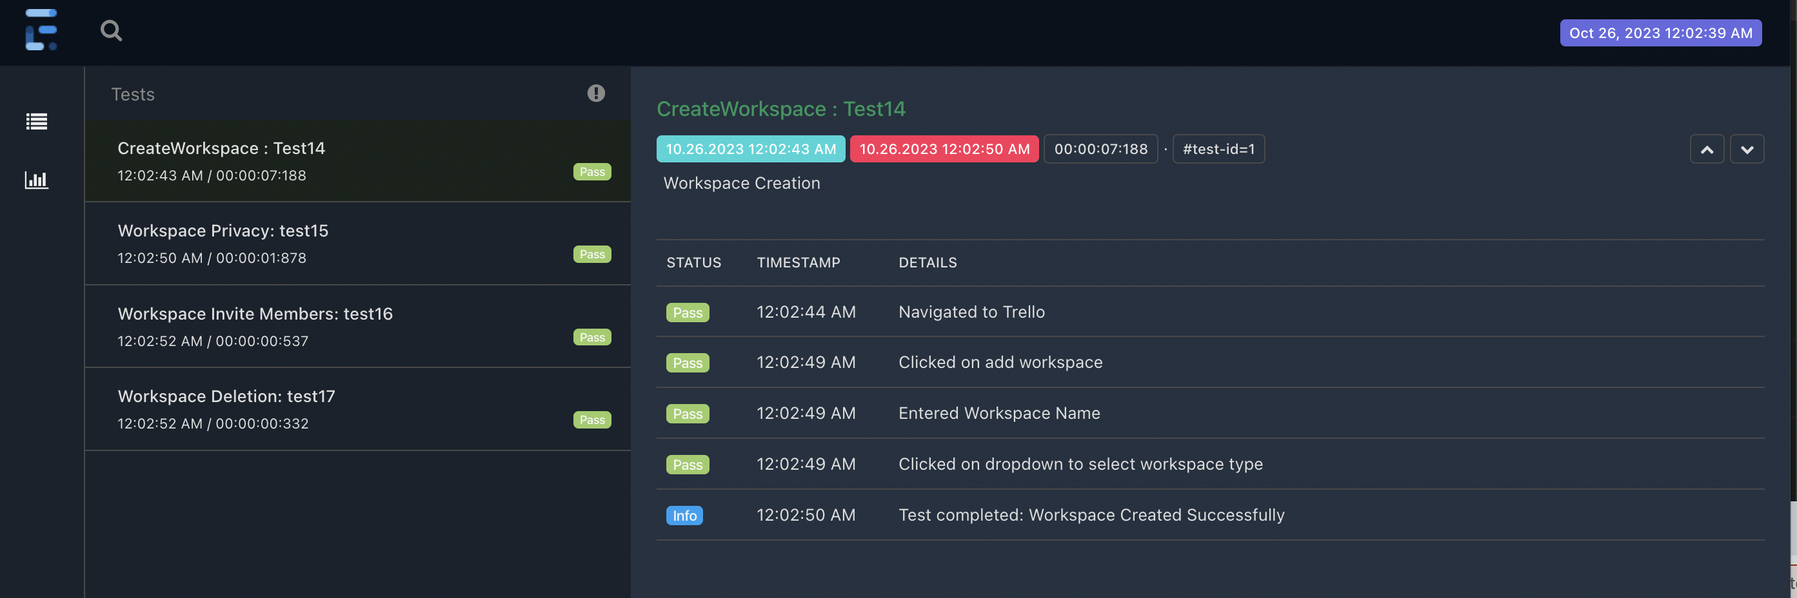

***Test 15: Verify that user can change workspace visibility.***

Clicked on Workspace settings button.

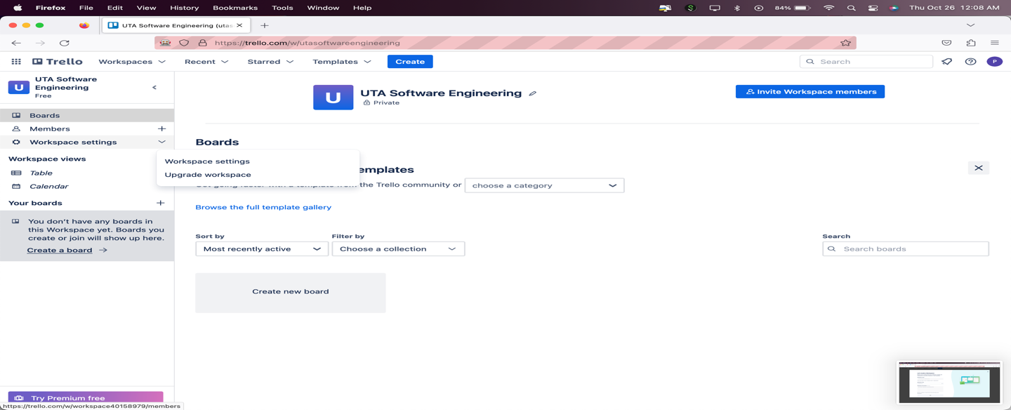

Clicked on change button and privacy changed.

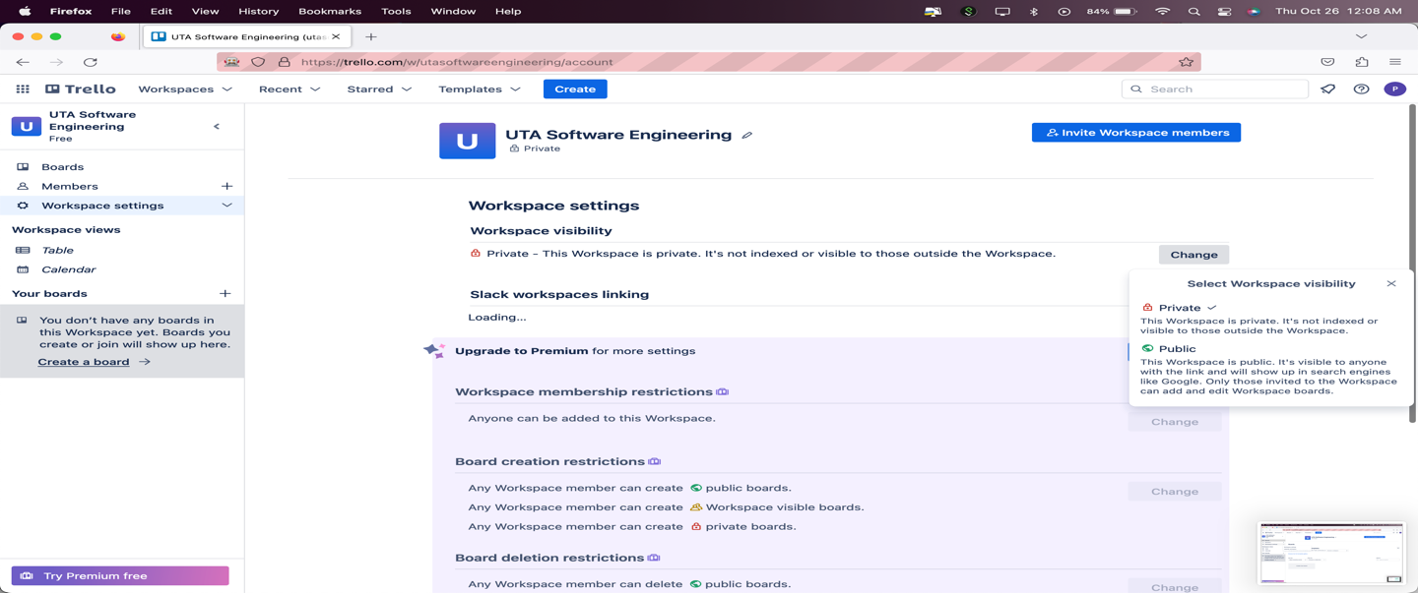

Privacy change to public from private.

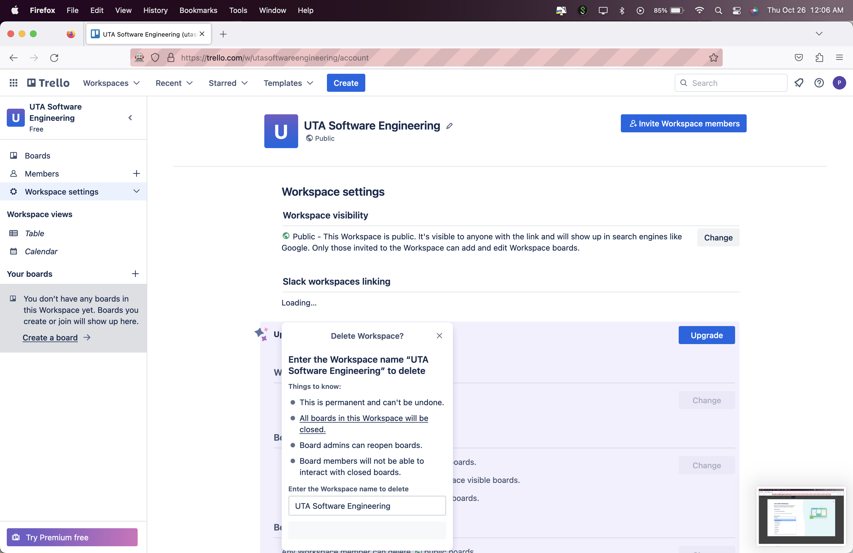

**Test 15: Report: Status: Pass**

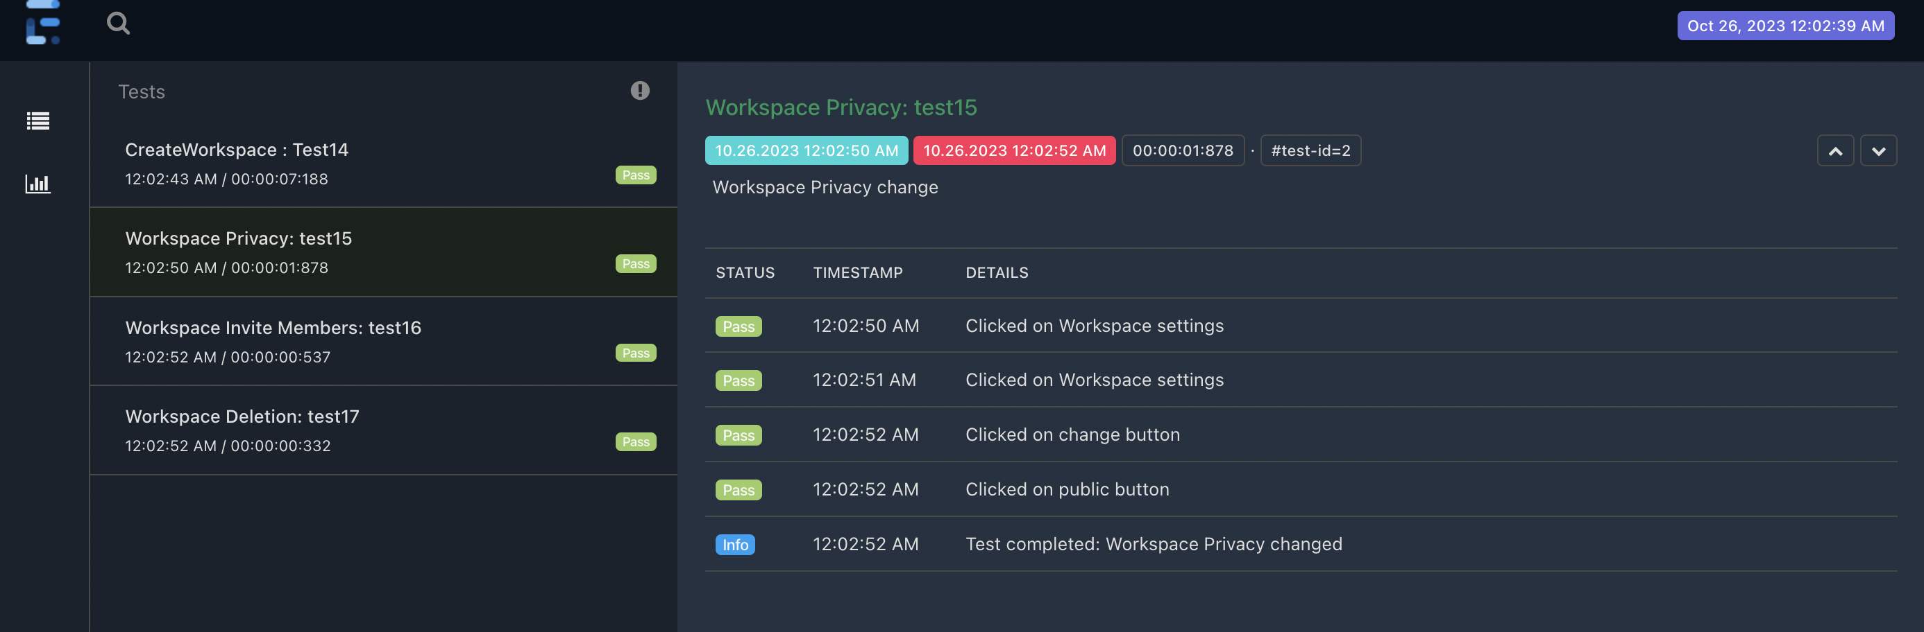

***Test 16: Verify that user can invite workspace members.***

Clicked on invite button and then entered member email id and then send button.

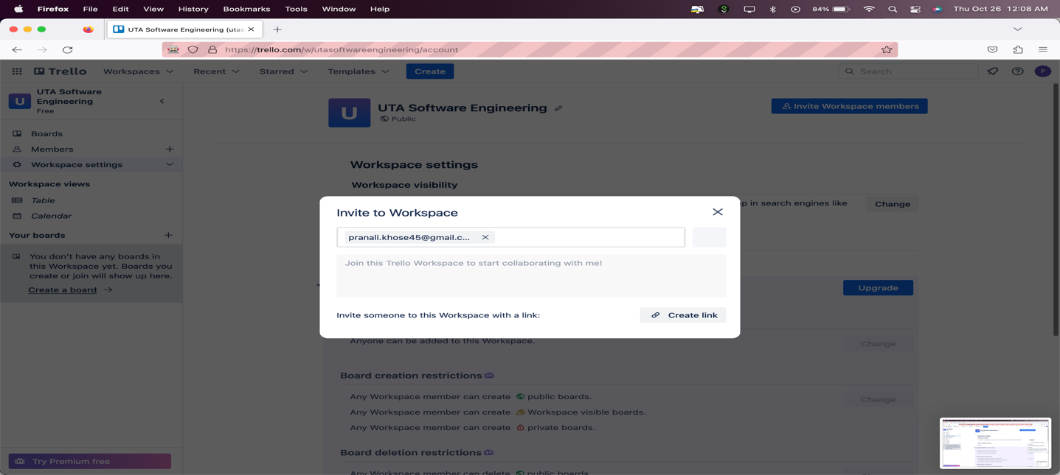

Member was invited:

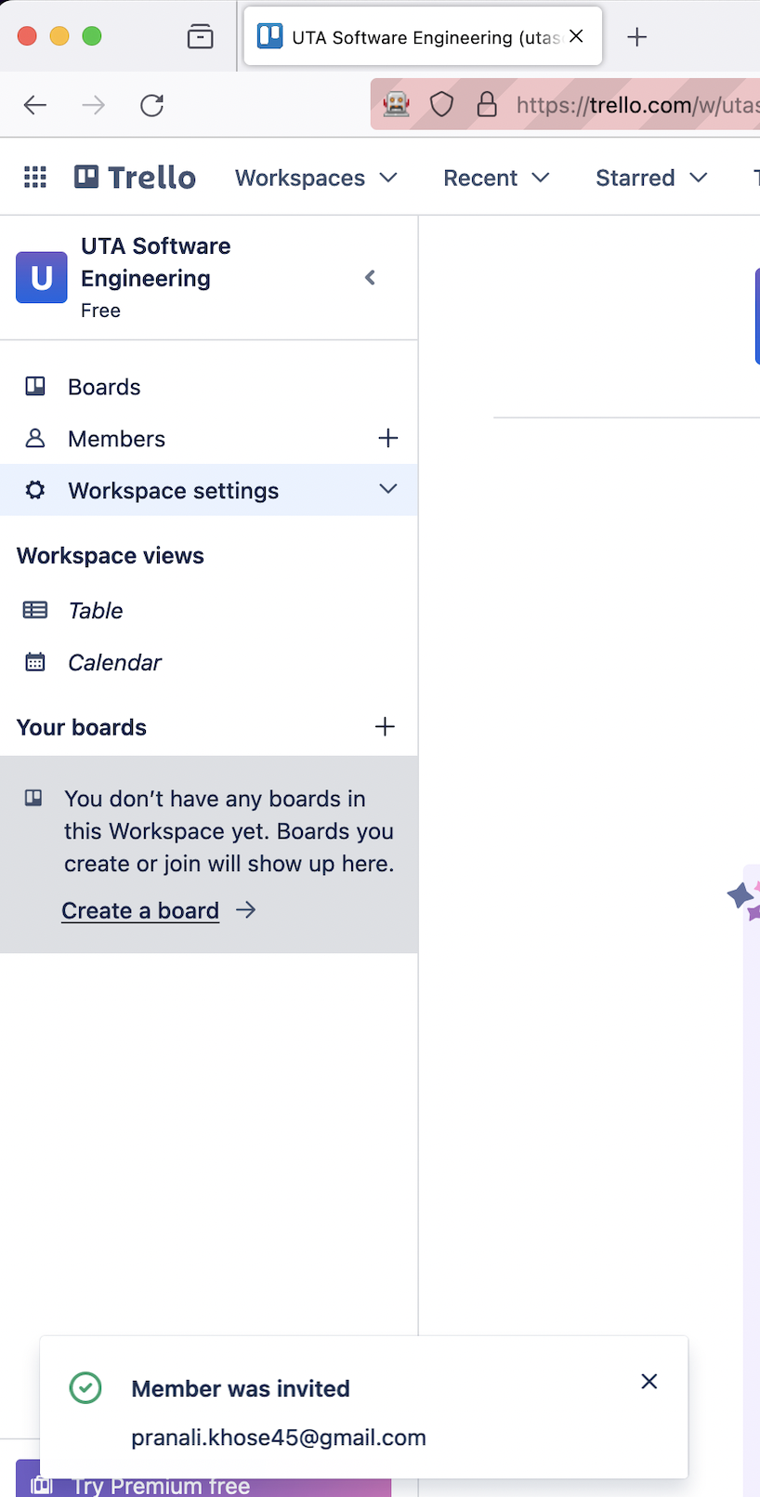

**Test 16: Report: Status: Pass**

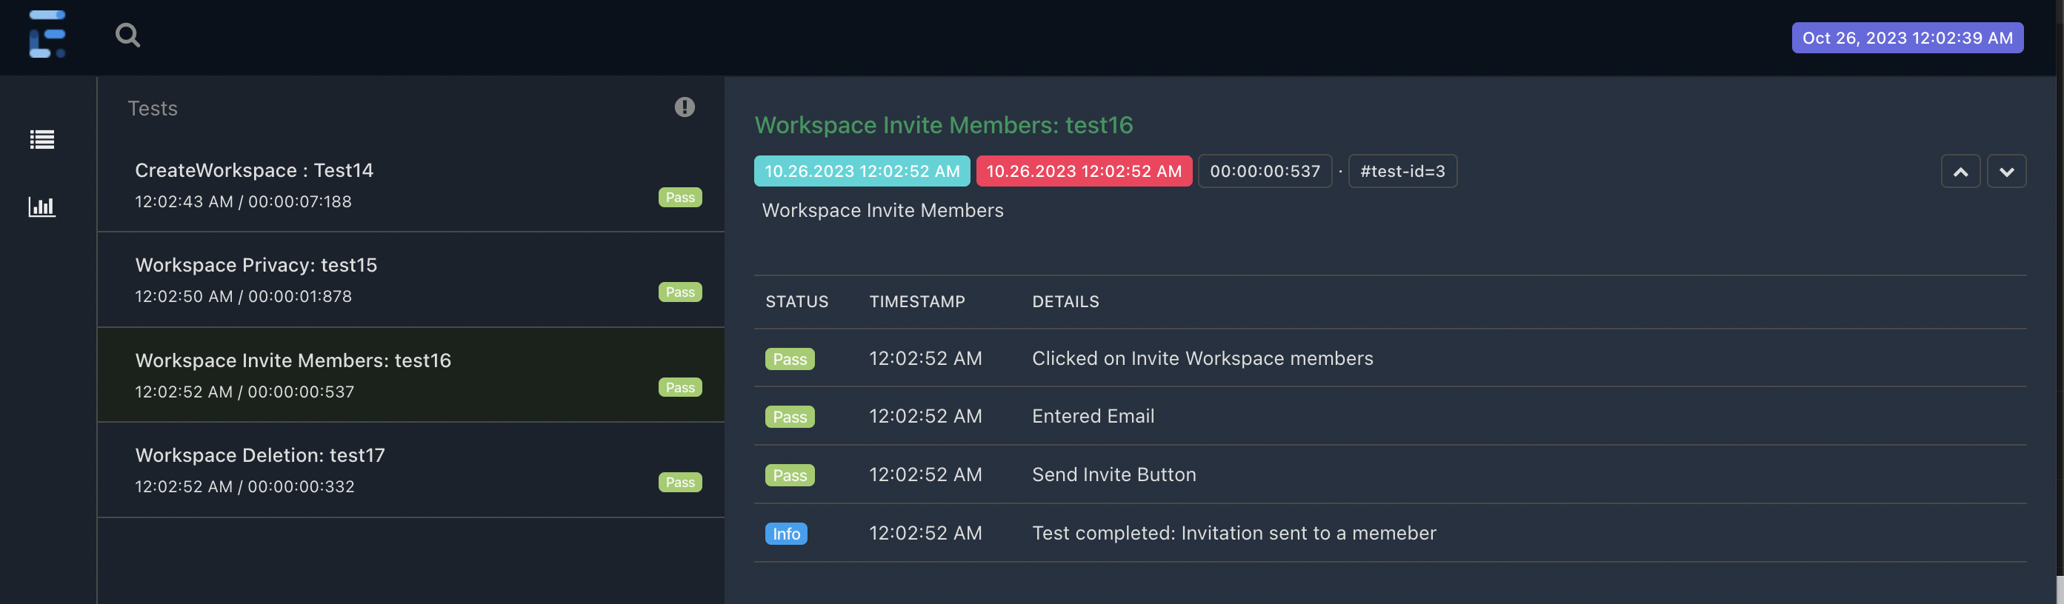

***Test 17: Verify that user can delete the workspace.***

Entered workspace name and delete button. Workspace Deleted.



*Test 17: Report: Status:* Pass

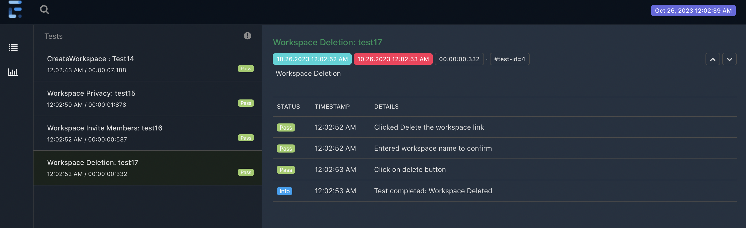

*All test cases from WorkspaceForTeamsTests suite are passed.*

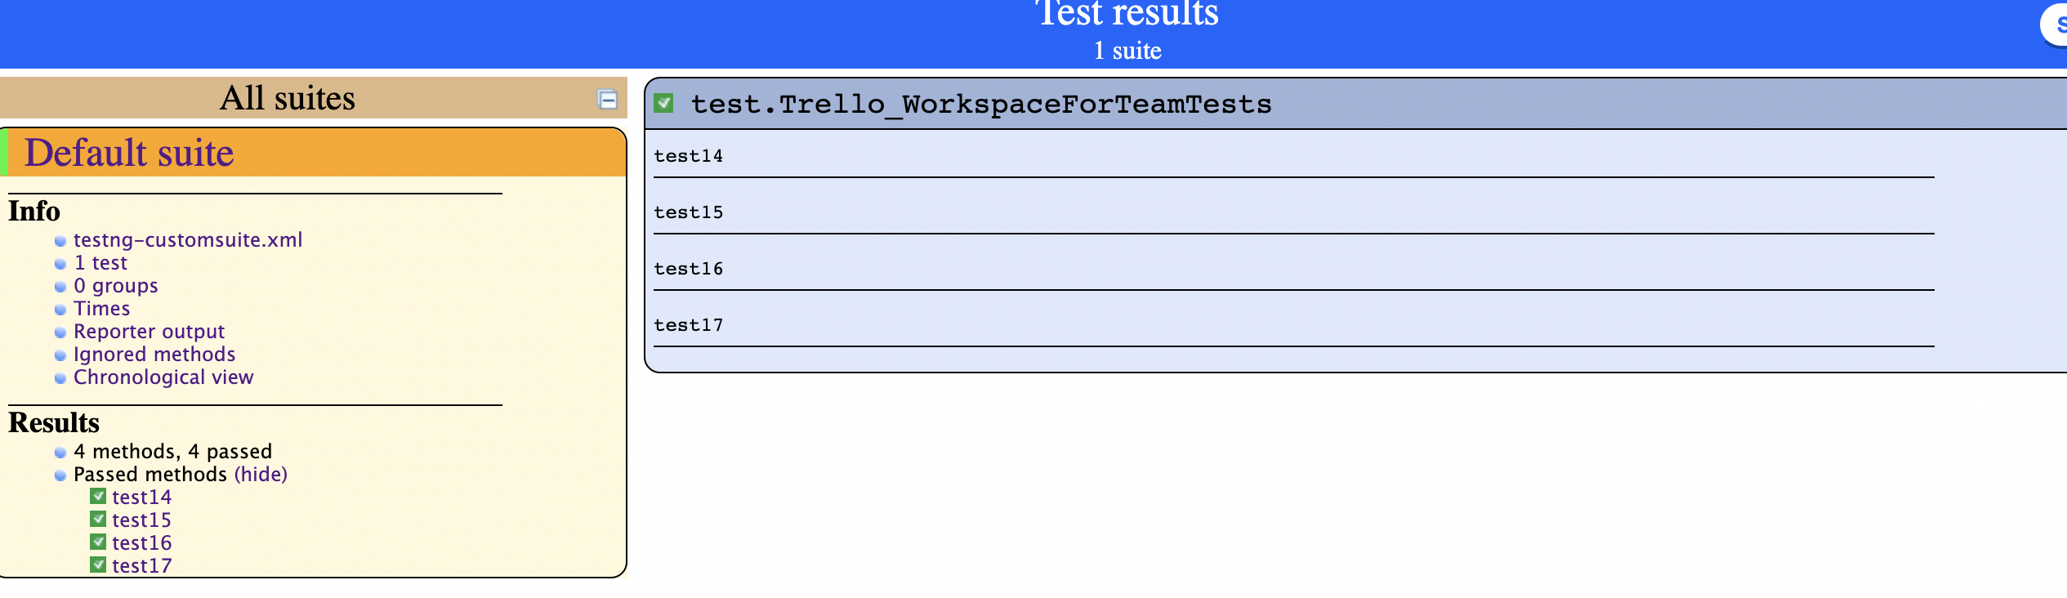

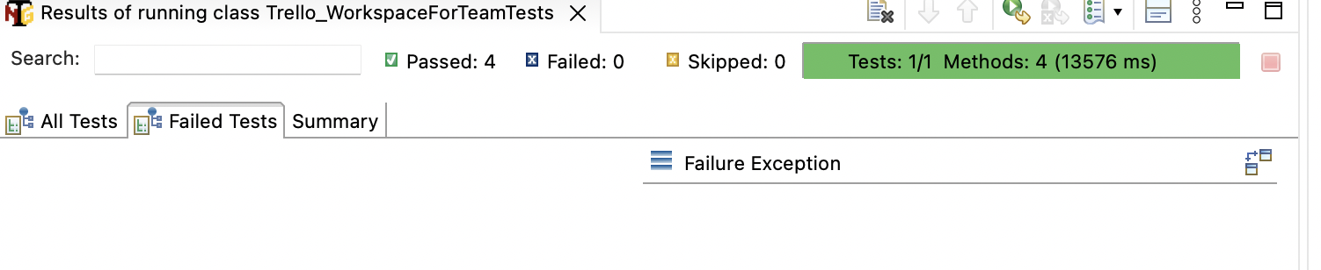

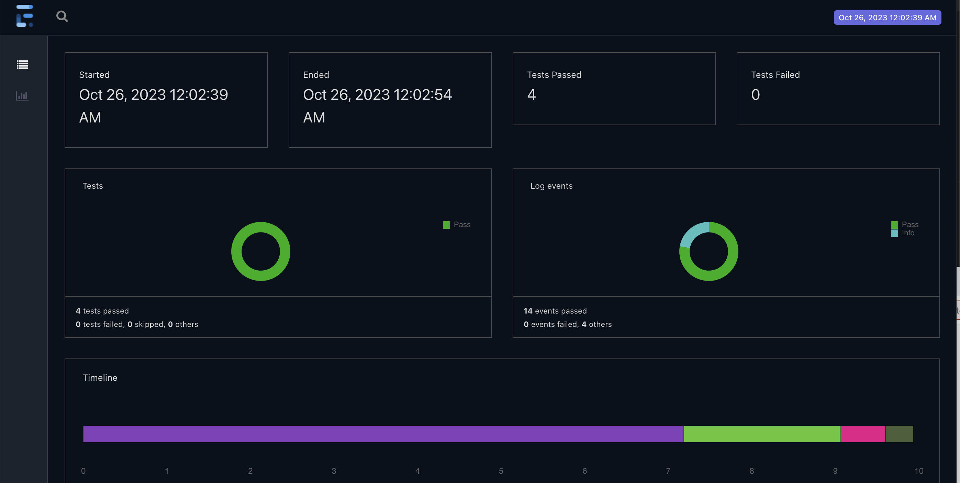

**Trello Automation using Selenium Summary:**

|  |  |  |  |  |
| --- | --- | --- | --- | --- |
| No. | Total Test Cases | Pass Count | Fail Count | Defect Found |
| 1. | 17 | 16 | 1 | 0 |

**Failed Test case**: Test Case 10: Verify that user can sign up with valid email Id.

**Failure Description:**

As per,<https://www.selenium.dev/documentation/test_practices/discouraged/captchas/>

It is not recommended to automate Captcha. Hence marked test case failed as we can’t test further.